SAP NetWeaver on Microsoft Azure Virtual Machine Services – Deployment Guide
Microsoft Corporation

Version: 2.00
Date of last change: 08/20/2015

Abstract
Microsoft Azure enables companies to acquire compute and storage resources in minimal time without lengthy procurement cycles. Azure Virtual Machines allows companies to deploy classical applications, like SAP NetWeaver based applications into Azure and extend their reliability and availability without having further resources available on-premises. Azure Virtual Machine Services also supports cross-premises connectivity, which enables companies to actively integrate Azure Virtual Machines into their on-premises domains, their Private Clouds and their SAP System Landscape.
This white paper describes step by step how a Microsoft Azure Virtual Machine is prepared for the deployment of SAP NetWeaver based applications. It assumes that the information contained in the ‘SAP NetWeaver on Microsoft Azure Virtual Machine Services – Planning and Implementation Guide’ is known. If not, the respective document should be read first.
The paper complements the SAP Installation Documentation and SAP Notes which represent the primary resources for installations and deployments of SAP software on given platforms.
Copyright Information

This document is provided "as-is". Information and views expressed in this document, including URL and other Internet website references, may change without notice.

Some examples depicted herein are provided for illustration only and are fictitious. No real association or connection is intended or should be inferred.

This document does not provide you with any legal rights to any intellectual property in any Microsoft product. You may copy and use this document for your internal, reference purposes.

Microsoft, Active Directory, Hyper-V, SQL Server, Windows PowerShell, Windows, Microsoft Azure and Windows Server are either registered trademarks or trademarks of Microsoft Corporation in the United States and/or other countries. All other trademarks are property of their respective owners.

© 2014 Microsoft Corporation. All rights reserved.

Contents
1 Introduction 5
2 Prerequisites and Resources 6
2.1 Prerequisites 6
2.2 Resources 7
3 Deployment Scenarios of VMs for SAP in Azure 8
3.1 Deployment of VMs for SAP 8
3.2 Scenario 1: Deploying a VM out of the Azure Gallery for SAP 9
3.3 Scenario 2: Deploying a VM with a customer specific image for SAP 12
3.4 Scenario 3: Moving a VM from on-premises using a non-generalized Azure VHD with SAP 16
3.5 Scenario 4: Deploying Monitoring for SAP into already deployed and productive VM 19
3.6 Scenario 5: Updating the Monitoring Configuration for SAP 19
4 Detailed Single Deployment Steps 21
4.1 Deploying Azure PowerShell cmdlets 21
4.2 Download and Import SAP relevant PowerShell cmdlets 23
4.3 Join VM into on-premises Domain 23
4.4 Download, Install and enable Azure VM Agent 23
4.5 Configure Azure Monitoring Extension for SAP 24
5 Checks and Troubleshooting for End-to-End Monitoring Setup for SAP on Azure 27
5.1 Readiness Check for Azure Monitoring for SAP 27
5.2 Health check for Azure Monitoring Infrastructure Configuration 30
5.3 Further troubleshooting of Azure Monitoring infrastructure for SAP 32
5.3.1 Azure performance counters do not show up at all 32
5.3.2 Some Azure performance counters are missing 33

Introduction
A large number of companies worldwide use SAP NetWeaver based applications – most prominently the SAP Business Suite – to run their mission critical business processes. System health is therefore a crucial asset, and the ability to provide enterprise support in case of a malfunction, including performance incidents, becomes a vital requirement.
Microsoft Azure provides superior platform instrumentation to accommodate the supportability requirements of all business critical applications. This guide makes sure that a Microsoft Azure Virtual Machine targeted for deployment of SAP Software is configured such that enterprise support can be offered, regardless which way the Virtual Machine gets created, be it taken out of the Azure gallery or using a customer specific image.
In the following, all necessary setup steps are described in detail.

Prerequisites and Resources

Prerequisites
Before you start, please make sure that the following prerequisites are met:
Local Personal Computer
The setup of an Azure Virtual Machine for SAP Software deployment comprises of several steps, in one of which a PowerShell script needs to be executed and the Microsoft Azure Portal needs to be accessed. For that, a local Personal Computer running Windows 7 or higher is necessary.
Internet connection
To download the Azure PowerShell cmdlets as well as a PowerShell script related to SAP deployments an Internet connection is required. In addition, the Internet connection is used by the PowerShell script related to SAP deployments to remotely interact with the Microsoft Azure Virtual Machine Service.
Furthermore, the Microsoft Azure Virtual Machine running the SAP Monitoring needs access to the Internet. In case this Azure VM is part of an Azure Virtual Network or on-premises domain, make sure that the relevant proxy settings are set. These settings must also be valid for the LocalSystem account to access the Internet.
Microsoft Azure Subscription
An Azure account already exists and according Logon credentials are known.
Topology consideration and Networking
The topology and architecture of the SAP deployment in Azure needs to be defined. Architecture in regards to:
- Microsoft Azure Storage account to be used
- Virtual Network to deploy the SAP system into
- Cloud Service to deploy the SAP system into
- Azure Region to deploy the SAP system
- SAP configuration (2-Tier or 3-Tier)
- VM size(s) and number of additional VHDs to be mounted to the VM(s)
- SAP Transport and Correction system configuration
should be defined. Azure Storage Accounts or Azure Virtual Networks as such should have been created and configured already. How to create and configure them is covered in the ‘SAP NetWeaver on Microsoft Azure Virtual Machine Services – Planning and Implementation Guide’.
SAP Sizing
- The projected SAP workload has been determined, e.g. by using the SAP Quicksizer, and the according SAPS number is known
- The required CPU resource and memory consumption of the SAP system should be known
- The required I/O operations per second should be known
- The required network bandwidth in eventual communication between different VMs in Azure is known
- The required network bandwidth between the on-premises assets and the Azure deployed SAP systems is known

Resources
During the configuration work, the following resources are needed:
SAP Note 1928533 – SAP Applications on Azure: Supported Products and Sizing, containing
- the list of Azure Machine types, which are supported for the deployment of SAP Software
- important capacity information per Azure Machine type
- supported SAP software and OS and DB combination
SAP Note 2015553 - SAP on Microsoft Azure: Support Prerequisites, listing prerequisites to be supported by SAP when deploying SAP software into Azure.
SAP Note 1999351 – Enhanced Azure Monitoring for SAP containing additional troubleshooting information for the Enhanced Azure Monitoring for SAP.
SAP Note 2178632 - Key Monitoring Metrics for SAP on Microsoft Azure containing detail information on all available monitoring metrics for SAP on Azure.
SAP Note 1409604 – Virtualization on Windows: Enhanced Monitoring containing the required SAP Host Agent version for Azure.
Link to download area for SAP specific PowerShell cmdlets:
http://go.microsoft.com/?linkid=9811175&clcid=0x409
Link to the Microsoft Azure Portal page: https://manage.windowsazure.com/
The following guides cover the topic of SAP on Azure as well:
- SAP NetWeaver on Microsoft Azure Virtual Machine Services – Planning and Implementation Guide
- SAP NetWeaver on Microsoft Azure Virtual Machine Services – Deployment Guide (this document)
- DBMS Deployment Guide for SAP on Microsoft Azure Virtual Machine Services
- SAP NetWeaver: Building a Microsoft Azure–based Disaster Recovery Solution
- Clustering SAP ASCS/SCS Instance using Windows Server Failover Cluster on Azure with SIOS DataKeeper

Deployment Scenarios of VMs for SAP in Azure
In this chapter you learn the different ways of deployment and the single steps to be taken for each way.

Deployment of VMs for SAP
Microsoft Azure offers multiple ways to deploy VMs and associated disks. Thereby it is very important to understand the differences since preparations of the VMs might differ dependent on the way of deployment. In general, we look into the following scenarios:
- Deploying a VM out of the Azure Gallery
You like to take a Microsoft or 3rd party provided image out of the Azure Gallery to deploy your VM. After you deployed your VM in Azure, you follow the same guidelines and tools to install the SAP software inside your VM as you would do in an on-premises environment. For installing the SAP software inside the Azure VM, SAP and Microsoft recommend to upload and store the SAP installation media in Azure VHDs or to create an Azure VM working as a ‘File server’ which contains all the necessary SAP installation media.
- Deploying a VM with a customer specific image
Due to specific patch requirements in regards to your OS or DBMS version, the provided images out of the Azure Gallery might not fit your needs. Therefore, you might need to create a VM using your own ‘private’ OS/SQL Server VM image which can be deployed several times afterwards.
To prepare such a ‘private’ image for duplication, the Windows settings (like Windows SID and hostname) must be abstracted/generalized on the on-premises VM; this can be done using sysprep. If you have already installed SAP content in your on-premise VM (especially for 2-Tier systems), you can adapt the SAP system settings after the deployment of the Azure VM through the System Rename procedure supported by the SAP Software Provisioning Manager (SAP Note 1619720 - System Rename for SAP Systems based on SAP NetWeaver).
Otherwise you can install the SAP software later after the deployment of the Azure VM.
As of the database content used by the SAP application, you can either generate the content freshly by an SAP installation or you can import your content into Azure by using a VHD with a DBMS database backup or by leveraging capabilities of the DBMS to directly backup into Microsoft Azure Storage (see the guide: ‘DBMS Deployment Guide for SAP on Microsoft Azure Virtual Machine Services’). In this case, you could also prepare VHDs with the DBMS data and log files on-premises and then import those as Disks into Azure. But the transfer of DBMS data which is getting loaded from on-premises to Azure would work over VHD disks that need to be prepared on-premises.
- Moving a VM from on-premises to Azure with a non-generalized disk
You plan to move a specific SAP system from on-premises to Azure. This can be done by uploading the VHD which contains the OS, the SAP Binaries and eventual DBMS binaries plus the VHDs with the data and log files of the DBMS to Azure. In opposite to scenario #2 above, you keep the hostname, SAP SID and SAP user accounts in the Azure VM as they were configured in the on-premises environment. Therefore, preparing the image by calling sysprep is not necessary. This case will mostly apply for Cross-Premises scenarios where a part of the SAP landscape is run on-premises and parts on Azure.

Scenario 1: Deploying a VM out of the Azure Gallery for SAP
Azure offers the possibility to deploy a VM instance out of a standard gallery which offers some standard OS images of Windows Server 2008R2 and Windows Server 2012 (R2). It is also possible to deploy an image that includes DBMS SKUs of SQL Server. For details using those gallery images with DBMS SKUs please refer to the document: ‘DBMS Deployment Guide for SAP on Microsoft Azure Virtual Machine Services’
The SAP specific sequence of steps deploying a VM out of the Azure gallery would look like:
Figure 1 Flowchart of VM deployment for SAP systems using a VM image in Azure gallery
Following the Flowchart the following steps need to be executed:
Step 1
Deploy Azure PowerShell cmdlets on Administration workstation as described in chapter 4.1 of this document.
Step2
Download and Import Azure Monitoring for SAP PowerShell cmdlets as described in chapter 4.2 of this document.
Step3
Deployment through Azure Portal
To start the deployment through Azure Portal, use the Wizard to create a new VM. The selection screen looks like this:

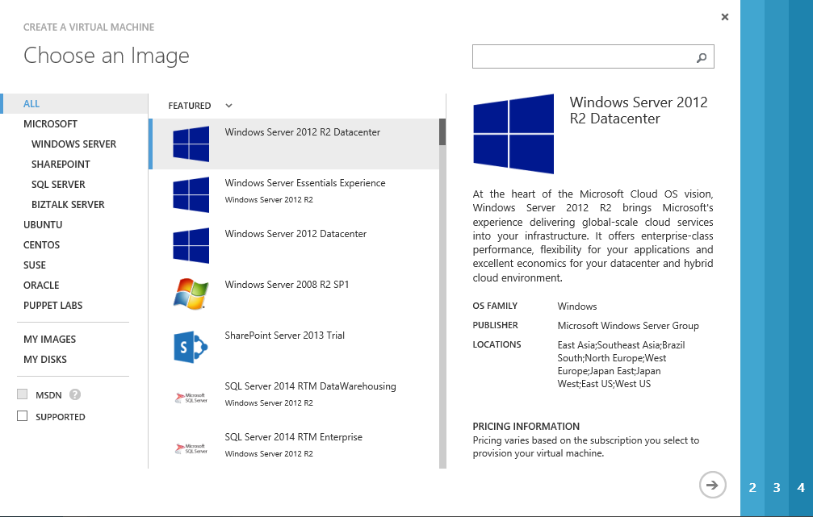
Figure 2 Standard Gallery Image selection
When going through the wizard, you need to provide the following information:
- Name and size of the VM,
- Administrator user name and password,
- Storage Account the VM needs to be deployed into (principles explained in implementation guide),
- Virtual Network and Cloud Service which this VM should be assigned to (principles explained in implementation guide),
- Fact whether the VM should be part of an Azure Availability Set (principles explained in planning and implementation guide),
- Endpoints – need to know whether default endpoints (RDP and Remote PowerShell should remain or whether additional Endpoints need to be configured).
- Please note: The Pre-selected option to ‘Install the VM Agent’ as shown below in Figure 3 needs to remain selected. The SAP Monitoring solution is relying on this Agent to be installed once the VM is deployed.
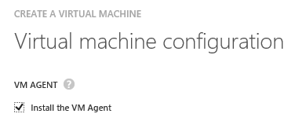
Figure 3 Pre-Selected Installation of VM Agent
Deployment through PowerShell cmdlets
Using PowerShell, a sequence of PS cmdlets to deploy such a VM could be structured like:
- Search the VM image to be deployed with the PS cmdlet: Get-AzureVMImage
This command will list all the global as well as private images which are accessible for the Azure subscription. Choose the gallery image desired.
A sequence of PS commands which deploys a VM out of the global gallery could look like:
- select-azuresubscription -Subscriptionname "My SAP Azure Landscape"
- set-azuresubscription -subscriptionname "My SAP Azure Landscape" -Currentstorageaccountname "SAPDEV"
- New-AzureVMConfig -Name "SAPERPDV2" -InstanceSize D11 -ImageName "Name of the image displayed by the Get-AzureVMImage cmdlet" | Add-AzureProvisioningConfig –Windows -AdminUsername "myadmin" –Password "strongpassword" | New-AzureVM –ServiceName "sapazureland"
Please note: In this deployment method it is required to specify the current storage account. Since the image of the VM is a global image provided by Azure, a storage account within the subscription needs to be defined in which the VM gets deployed. This is done with the PS cmdlet ‘set-azuresubscription’ which is used to set the current or default storage account for the Azure subscription specified in the same command. Please be aware that the commands above are leaving out several configuration options the Azure Portal Wizard is asking. E.g. Endpoints or Availability Sets are not configured. The different PS cmdlets which were piped in the third command are allowing a whole set of other options which allow definitions as the wizard does. Please check the help of the specific commands with:
get-help <cmdlet name>
or check the help in MSDN for the specific parameters of the commands.
Please note that the Azure VM Agent is deployed by default when deploying a VM through a sequence of PowerShell cmdlets as described above.
Step 4
In the case that the deployment in Azure is connected to the on-premises AD/DNS via Azure Site-to-Site or Express Route (also referenced as Cross-Premises in the ‘SAP NetWeaver on Microsoft Azure Virtual Machine Services – Planning and Implementation Guide’), it is expected that the VM is joining an on-premises domain. Considerations of this step are described in chapter 4.3 of this document.
Step 5
Configure Azure Monitoring Extension for SAP as described in chapter 4.5 of this document.
Check the prerequisites for SAP Monitoring for required minimum versions of SAP kernel and SAP Host Agent in the resources listed in chapter 2.2 of this document.
After creating the VM, it will be deployed and it is then on you to install all the necessary software components into the VM. Hence this type of VM deployment would require either the software to be installed already available in Azure in some other VM or as disk which can be attached. Or we are looking into Cross-Premises scenarios where connectivity to the on-premises assets (install shares) is a given.

Scenario 2: Deploying a VM with a customer specific image for SAP
As described in the ‘SAP NetWeaver on Microsoft Azure Virtual Machine Services – Planning and Implementation Guide’ already in detailed steps there is a way to prepare and create a ‘custom’ image and have it uploaded into the private gallery of Azure.
The sequence of steps in the flow chart would look like:
Figure 4 Flowchart of VM deployment for SAP systems using a VM image in Private Image gallery
Following the Flowchart the following steps need to be executed:
Step 1
Deploy Azure PowerShell cmdlets on Administration workstation as described in chapter 4.1 of this document.
Step2
Download and Import Azure Monitoring for SAP PowerShell cmdlets as described in chapter 4.2 of this document.
Step3
Start the deployment of the desired VM Image out of the Microsoft Azure gallery or through PowerShell cmdlets.
Deployment through Azure Portal
When deploying such an image the sequence of deployment would look like:
- Use the Wizard to create a new VM.
- In opposite to selecting the image out of the global gallery, the image would be picked out of the section ‘My Images’ (see Figure 5 below).
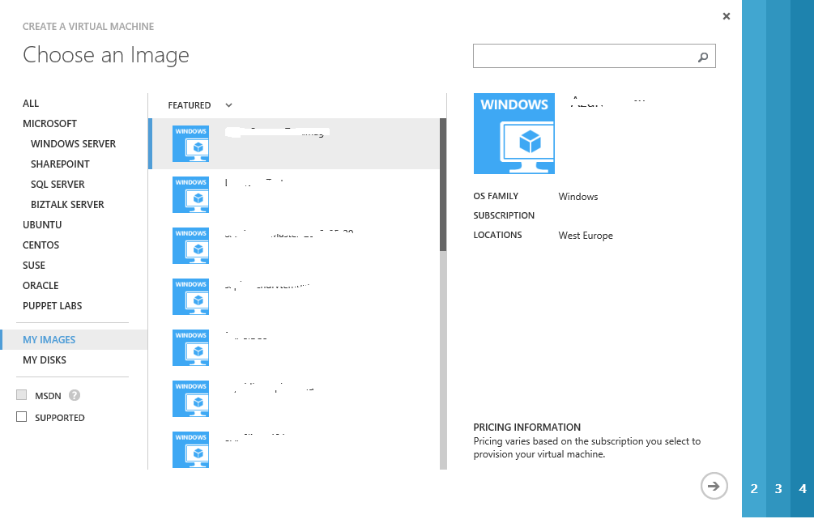
Figure 5 Deploying an own image out the private Image gallery of an Azure Subscription
When going through the wizard, you need to provide the following information:
- Name and size of the VM,
- Administrator user name and password,
- It is NOT necessary to define a storage account name since the VM would be deployed in the same storage account as you placed the custom VM image in. This is a significant difference compared to deployments from a global gallery image,
- Virtual Network and Cloud Service which this VM should be assigned to (principles explained in implementation guide),
- Fact whether the VM should be part of an Azure Availability Set (principles explained in implementation guide),
- Endpoints – need to know whether default endpoints (RDP and Remote PowerShell should remain or whether additional Endpoints need to be configured).
- Please note: The Pre-selected option to ‘Install the VM Agent’ as shown above in Figure 3 needs to remain selected. The SAP Monitoring solution is relying on this Agent to be installed once the VM is deployed.
Deployment through PowerShell cmdlets
Using PowerShell, a sequence of PS cmdlets to deploy such a VM could be structured like:
- Search the VM image to be deployed with the PS cmdlet: Get-AzureVMImage
This command will list all the global as well as private images which are accessible for the Azure subscription. Choose the private image desired.
A sequence of PS commands which deploys a VM out of the global gallery could look like:
- select-azuresubscription -Subscriptionname "My SAP Azure Landscape"
- set-azuresubscription -subscriptionname "My SAP Azure Landscape" -Currentstorageaccountname "storage account that holds the private image"
- New-AzureVMConfig -Name "SAPERPDV2" -InstanceSize D11 -ImageName "Name of the image displayed by the Get-AzureVMImage cmdlet" | Add-AzureProvisioningConfig –Windows -AdminUsername "myadmin" –Password "strongpassword" | New-AzureVM –ServiceName "sapazureland"
In this deployment specify as storage account the storage account the private VM Image is stored in. The VM will be deployed in the storage account in which the image is located. This is done with the PS cmdlet ‘set-azuresubscription’ which is used to set the current or default storage account for the Azure subscription specified in the same command. Please be aware that the commands above are leaving out several configuration options the Azure Portal Wizard is asking. E.g. Endpoints or Availability Sets are not configured. The different PS cmdlets which were piped in the third command are allowing a whole set of other options which allow definitions as the wizard does. Please check the help of the specific commands with:
get-help <cmdlet name>
or check the help in MSDN for the specific parameters of the commands.
Step 4
In the case that the deployment in Azure is connected to the on-premises AD/DNS via Azure Site-to-Site or Express Route (also referenced as Cross-Premises in the ‘SAP NetWeaver on Microsoft Azure Virtual Machine Services – Planning and Implementation Guide’), it is expected that the VM is joining an on-premises domain. Considerations of this step are described in chapter 4.3 of this document.
Step 5
Configure Azure Monitoring Extension for SAP as described in chapter 4.5 of this document.
Check the prerequisites for SAP Monitoring for required minimum versions of SAP kernel and SAP Host Agent in the resources listed in chapter 2.2 of this document.

Scenario 3: Moving a VM from on-premises using a non-generalized Azure VHD with SAP
This scenario is addressing the case of a SAP system simply being moved in its current form and shape from on-premises to Azure. Means no name change of the Windows hostname and SAP SID or something like that takes place. In this case the VM itself is not registered as an image with Azure, but as Azure Disk. In regards to the deployment, this case differs from the two former cases by the fact that Azure Virtual Machine Services is not able to inject the Azure Guest Service into the VM. Therefore, the Azure VM Agent needs to be downloaded from Microsoft and needs to be installed and enabled within the VM manually afterwards. After that task succeeded, you can continue to initiate the SAP Host Monitoring Azure Extension and its configuration. For details on the function of the Azure VM Agent, please check this article: http://blogs.msdn.com/b/wats/archive/2014/02/17/bginfo-guest-agent-extension-for-azure-vms.aspx
The workflow of the different steps looks like:
Figure 6 Flowchart of VM deployment for SAP systems using a VM Disk in the Private Disk gallery
Assuming that the Disk is already uploaded and defined in Azure (see ‘SAP NetWeaver on Microsoft Azure Virtual Machine Services – Planning and Implementation Guide’), follow these steps
Step 1
Deploy Azure PowerShell cmdlets on Administration workstation as described in chapter 4.1 of this document.
Step2
Download and Import Azure Monitoring for SAP PowerShell cmdlets as described in chapter 4.2 of this document.
Step3
Start the deployment of the desired VM Disk out of the Microsoft Azure Private Disk gallery or through Azure PowerShell cmdlets.
Deployment through Azure Portal
When deploying such an image the sequence of deployment looks like:
- Use the Wizard to create a new VM.
- In opposite to select an image, you select the disk out of the section ‘My Disks’:
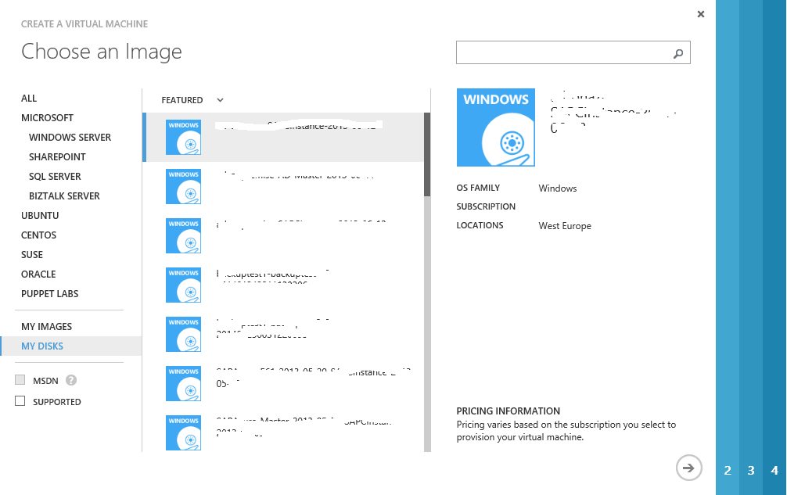
Figure 7 Deploying an own image out the private Disk gallery of an Azure Subscription
When going through the wizard, you need to provide the following information:
- Name of the VM. It is expected that the VM will get the same name in Azure as it has been already named on-premise,
- Size of the VM,
- Virtual Network and Cloud Service which this VM should be assigned to (principles explained in implementation guide),
- Fact whether the VM should be part of an Azure Availability Set (principles explained in implementation guide),
- Endpoints – need to know whether default endpoints (RDP and Remote PowerShell should remain or whether additional Endpoints need to be configured).
- It is NOT necessary to define a storage account name since the VM would be deployed in the same storage account as you placed the custom VM VHD in. This is a significant difference from deploying a global gallery image.
Deployment through PowerShell cmdlets
Using PowerShell, a sequence of PS cmdlets to deploy such a VM could be structured like:
- Search the VM Disk to be deployed with the PS cmdlet: Get-AzureDisk
This command will list all private Azure Disks of the subscriptions which are accessible for the user executing the command. Choose the private disk you want to use for the new Azure VM.
A sequence of PS commands which deploys a VM out of the global gallery could look like:
- select-azuresubscription -Subscriptionname "My SAP Azure Landscape"
- New-AzureVMConfig -Name "SAPERPDV2" -InstanceSize D11 -Diskname “SAPERPDEV2BASE” | New-AzureVM –ServiceName "sapazureland"
In this case no storage account is defined since the deployment will take place in the storage account the Azure Disk is stored in. Also the cmdlet ‘Add-AzureProvisioningconfig’ is not necessary since admin users, passwords, etc are already set in the VM since it is not syspreped. Please be aware that the commands above are leaving out several configuration options the Azure Portal Wizard is asking. E.g. Endpoints or Availability Sets are not configured. The different PS cmdlets which were piped in the second command are allowing a whole set of other options which allow definitions as the wizard does. Please check the help of the specific commands with:
get-help <cmdlet name>
or check the help in MSDN for the specific parameters of the commands.
Step 4
In the case that the deployment in Azure is connected to the on-premises AD/DNS via Azure Site-to-Site or Express Route (also referenced as Cross-Premises in the ‘SAP NetWeaver on Microsoft Azure Virtual Machine Services – Planning and Implementation Guide’), it is expected that the VM is joining an on-premises domain. Considerations of this step are described in chapter 4.3 of this document.
Step 5
Download and Install the VM Agent in the VM as described in chapter 4.4 of this document._Download_and_Install
Step 6
Configure Azure Monitoring Extension for SAP as described in chapter 4.5 of this document.
Check the prerequisites for SAP Monitoring for required minimum versions of SAP kernel and SAP Host Agent in the resources listed in chapter 2.2 of this document.

Scenario 4: Deploying Monitoring for SAP into already deployed and productive VM
Since quite a few customers already deployed SAP systems on Azure Virtual Machine Services, before Azure started to deploy the Azure VM Agent by default, there is a valid scenario that requires a post deployment distribution of the Azure Monitoring Extension for SAP into these already deployed systems. The sequence looks like:
- Make sure that you have installed the latest version of the Microsoft Azure PowerShell cmdlets. See chapter 4.1 of this document.
- Download and import the PowerShell Module to enable monitoring for SAP Systems as described in chapter 4.2 of this document.
- For VM joined in on-premises domains, make sure that eventual Internet proxy settings apply for the Windows LocalSystem account in the VM as well. The VM Agent will run in this context and needs to be able to connect to the internet.
- Download, install and enable the Azure VM Agent Installer Package as described in chapter 4.4 of this document.
- Configure the Azure Monitoring Extension for SAP as described in chapter 4.5 of this document
Check the prerequisites for SAP Monitoring for required minimum versions of SAP kernel and SAP Host Agent as described in chapter 2.2 of this document.

Scenario 5: Updating the Monitoring Configuration for SAP
There are four different cases where you would need to update the monitoring configuration:
- The joint MS/SAP team extended the monitoring capabilities and decided to add more counters or delete some counters.
- Microsoft introduces a new version of the underlying Azure infrastructure delivering the monitoring data, and the Azure Monitoring Extension for SAP is adapting to those changes.
- You add additional VHDs mounted to your Azure VM or you remove a VHD. In this case, you need to update the collection of storage related data. If you change your configuration by adding or deleting endpoints or assigning IP addresses to a VM, this will not impact the monitoring configuration.
- You change the size of your Azure VM e.g. from A5 to any other size of VM.
In order to update the monitoring configuration, proceed as follows:
- Update the monitoring infrastructure by following the steps explained in chapter 4.5 of this document.
A re-run of the script described in this chapter will detect that a monitoring configuration is deployed and will perform the necessary changes to the monitoring configuration.
For the update of the Azure VM Agent, no user intervention is required. VM Agent auto updates itself and does not require a VM reboot.

Detailed Single Deployment Steps

Deploying Azure PowerShell cmdlets
- Go to: http://www.windowsazure.com/en-us/downloads/.
- Under the section ‘Command-Line Tools’ there is a section called ‘Windows PowerShell’. Follow the ‘Install’ link.
- Microsoft Download Manager will pop-up with a line item ending with .exe. Select the option ‘Run’.
- A pop-up will come up asking whether to run Microsoft Web Platform Installer. Press YES
- A screen like this one appears:
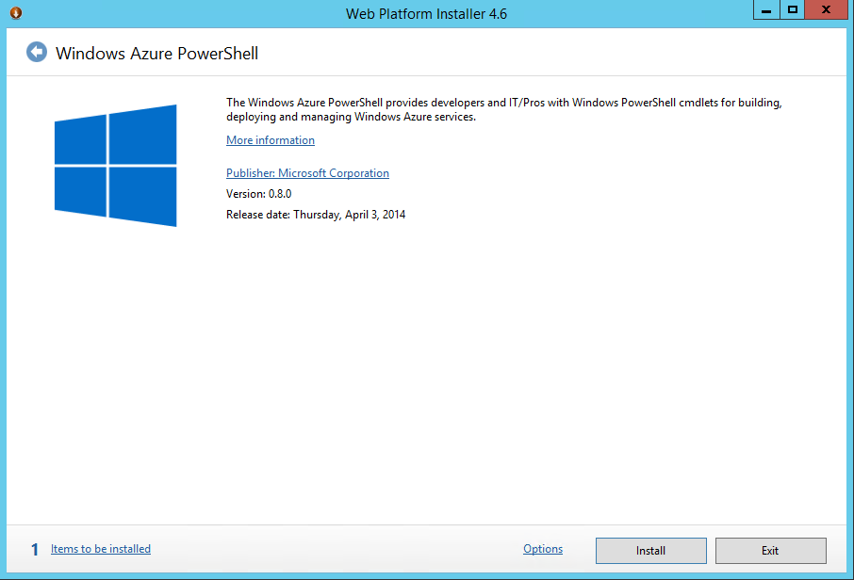
Figure 8 Installation screen for Azure PowerShell cmdlets for the case where no or obsolete Azure cmdlets are installed
- Press YES, acknowledge the EULA and the installation will start.
- After the installation, configure the cmdlets for the usage with the Azure subscription(s) as described here: http://www.windowsazure.com/en-us/documentation/articles/install-configure-powershell/?fwLinkID=320552
It also is possible that you need to create an Azure Management certificate. This step is described here: http://msdn.microsoft.com/en-us/library/windowsazure/gg981929.aspx
Check frequently whether the PowerShell cmdlets have been updated. Usually there are updates on a monthly period. The easiest way to do this is to follow the installation steps as described above up to the installation screen shown in Figure 8. In this screen the release date of the cmdlets is shown as well as the actual release number. Unless stated differently in SAP Notes, it is recommended to work with the latest version of Azure PowerShell cmdlets.
The current installed version of the Azure cmdlets on the desktop/laptop can be checked with the PS command: (get-module azure).version
The result should be presented as shown below in Figure 9
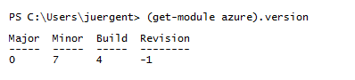
Figure 9 Result of Azure PS cmdlet version check
If the version shown in this check is different to the version shown in the screen as presented in this document as Figure 9, you should update/install the new version. If the PS version check command comes back with no result, execute the PS cmdlet ‘Add-AzureAccount’ and execute (get-module azure).version again.
If the Azure cmdlet version installed on the desktop/laptop is the current one, the first screen after starting the Microsoft Web PIatform Installer will look slightly different compared to the one shown in Figure 8.
Please notice the red circle below in Figure 10
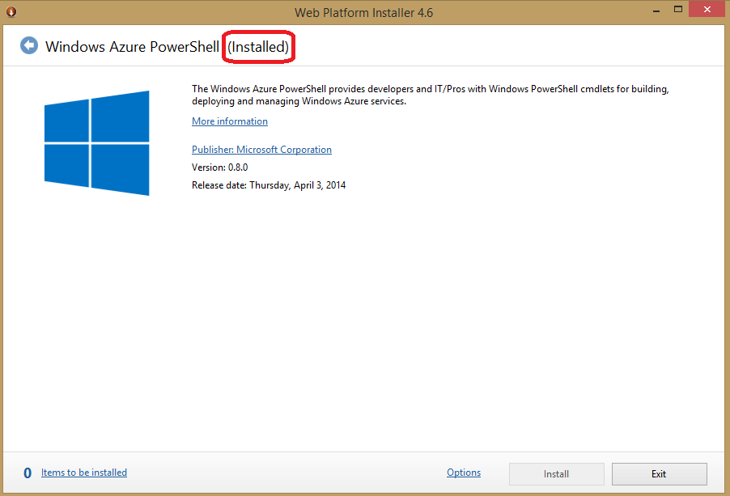
Figure 10 Installation screen for Azure PowerShell cmdlets indicating that most recent release of Azure PS cmdlets are installed
If the screen looks as above in Figure 10, indicating that the most recent Azure cmdlet version is already installed, there is no need to continue with the installation. In this case you can ‘Exit’ the installation at this stage.

Download and Import SAP relevant PowerShell cmdlets
- Download the PowerShell Module to enable monitoring for SAP Systems from http://gallery.technet.microsoft.com/Azure-Enhanced-extension-16ac0960
- Open a PowerShell console and set the execution level to unrestricted as follows:
Set-ExecutionPolicy -Scope Process Bypass
- Open a PowerShell console and import the module by executing
Import-Module <path to module>\saponazure.psm1
Details on the Import-Module PowerShell cmdlet can be found here: http://technet.microsoft.com/en-us/library/hh849725.aspx

Join VM into on-premises Domain
In cases where you deploy SAP VMs into a Cross-Premises scenario where on-premises AD and DNS is extended into Azure, it is expected that the VMs are joined in an on-premises domain. The detailed steps of joining an on-premises domain and additional software required to be a member of an on-premises domain is customer dependent. Usually joining a VM to an on-premises domain means installing additional software like Malware Protection software or various agents of backup or monitoring software.
Additionally, you need to make sure for cases where Internet proxy settings are forced when joining a domain, that the Windows LocalSystem Account in the Guest VM has these settings as well. Easiest is to force the proxy with Domain Group Policy which apply to systems within the domain.

Download, Install and enable Azure VM Agent
The following steps are necessary when a VM for SAP is getting deployed from non-sysprep’ed OS images or when SAP Monitoring should be enabled on VMs that got deployed without having the VM Agent installed during the deployment phase.
Download the Azure VM Agent:
- Download the Azure VM Agent installer package from: http://go.microsoft.com/fwlink/?LinkId=394789
- Store the VM Agent MSI package locally on the laptop or a server
Install the Azure VM Agent:
- Connect to the deployed Azure VM with Terminal Services (RDP)
- Open a Windows Explorer window on the VM and open a target directory for the MSI file of the VM Agent
- Drag and drop the Azure VM Agent Installer MSI file from your local laptop/server into the target directory of the VM Agent in the VM
- Double Click on the MSI file in the VM
- For VM joined in on-premise domains, make sure that eventual Internet proxy settings apply for the Windows LocalSystem account in the VM as well. The VM Agent will run in this context and needs to be able to connect to Azure.
Enable the Azure VM Agent:
- Run the PowerShell cmdlet Enable-ProvisionGuestAgent_GUI. The script will ask for the following input data:
  - Credentials for the Azure subscription
  - The name of the virtual machine you want to update

Configure Azure Monitoring Extension for SAP
Once the VM is prepared with the steps described in chapter 3.2 to 3.6 of this document, the Azure VM Agent is automatically deployed in the machine. The next important step is to deploy the Azure Monitoring Extension for SAP which is available in the Azure Extension Repository in the global datacenters of Azure. For more detail, please check chapter 9.1 of the guide: ‘SAP NetWeaver on Microsoft Azure Virtual Machine Services – Planning and Implementation Guide‘.
Please note: The installation of the Azure Monitoring Extension for SAP does not yet work with VMs that leverage Azure Premium Storage. Microsoft is working on adapting the Azure Monitoring Extension for SAP to:
- Fix the issue installing the Azure Monitoring Extension for SAP in VMs that leverage Premium Storage.
- Adapt the Extension to new Premium Storage SLAs in regards to I/O throughput that come with Premium Storage.
In order to perform the task of installing the Azure Monitoring Extension for SAP, perform the following steps:
- Make sure that you have installed the latest version of the Microsoft Azure PowerShell cmdlet. See chapter 4.1 of this document.
- Download and import the PowerShell Module to enable monitoring for SAP Systems as described in chapter 4.2 of this document.
- Run the PowerShell cmdlet Update-VMConfigForSAP_GUI. The script will ask for the following input data:
  - Credentials for the Azure subscription,
  - The name of the virtual machine you want to update.
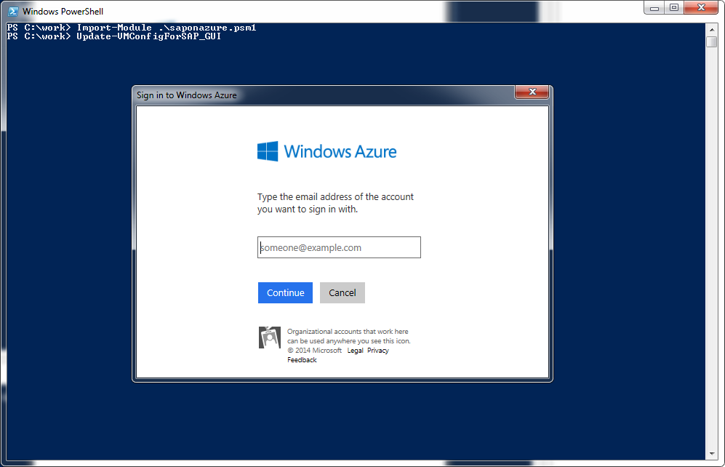
Figure 11 Input screen of SAP specific Azure cmdlet Update-VMConfigForSAP_GUI
After you provided your account data and the Azure Virtual Machine, the script will deploy the required extensions and enable the required features.
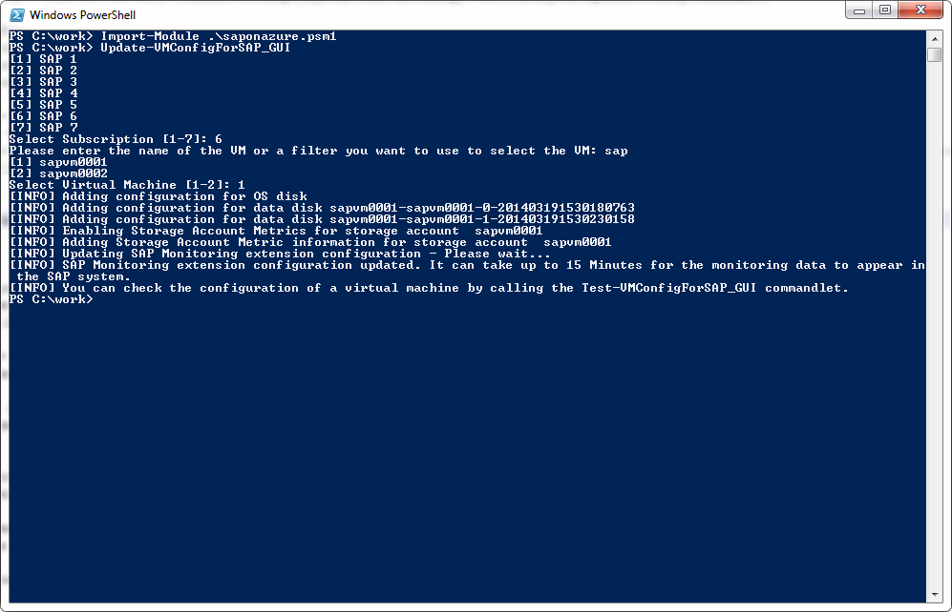
Figure 12 Result screen of successful execution of SAP specific Azure cmdlet Update-VMConfigForSAP_GUI
A successful run of Update-VMConfigForSAP_GUI will do all the steps necessary to configure the host monitoring functionality for SAP.
The output the script should deliver looks like:
- Confirmation that the monitoring configuration for the Base VHD (containing the OS) plus all additional VHDs mounted to the VM got configured.
- The next two messages are confirming the configuration of Storage Metrics for a specific storage account.
- One line of output will give a status on the actual update of the monitoring configuration.
- Another will show up confirming that the configuration has been deployed or updated.
- The last line of the output is informational showing the possibility to test the monitoring configuration.
- To check, that all steps of the Azure Monitoring have been executed successfully and that the Azure Infrastructure provides the necessary data, proceed with the Readiness check for Azure Monitoring Extension for SAP, as described in chapter 5.1 in this document.
- To continue doing this, wait for 15-30 minutes until the Windows Azure Diagnostics will have the relevant data collected.

Checks and Troubleshooting for End-to-End Monitoring Setup for SAP on Azure
After you have deployed your Azure VM and set up the relevant Azure monitoring infrastructure, check whether all the components of the Azure Monitoring are working in a proper way.
Therefore, execute the Readiness check for Azure Monitoring for SAP as described in chapter 5.1. If the result of this check is positive and you get all relevant performance counters, the Azure monitoring has been setup successfully. In this case, proceed with the installation of the SAP Host Agent as provided in the SAP Notes listed in chapter 2.2 of this document. If the result of the Readiness check indicates missing counters, proceed executing the Health check for the Azure Monitoring Infrastructure as described in chapter 5.2. In case of any problem with the Azure Monitoring Configuration, check chapter 5.3 for further help on troubleshooting.

Readiness Check for Azure Monitoring for SAP
With this check, you make sure that the metrics which will be shown inside your SAP application are provided completely by the underlying Azure Monitoring Infrastructure.
Execute the Readiness check
In order to execute the readiness check, logon to the Azure Virtual Machine (admin account is not necessary) and execute the following steps:
- Open a Windows Command prompt and change to the installation folder of the Azure Monitoring Extension for SAP
‘C:\Packages\Plugins\Microsoft.AzureCAT.AzureEnhancedMonitoring.AzureCATExtensionHandler\<version>\drop’.
The version part provided in the path to the monitoring extension above may vary.
If you see multiple folders of the monitoring extension version in the installation folder, check the configuration of the Windows service ‘AzureEnhancedMonitoring’ and switch to the folder indicated as ‘Path to executable’.
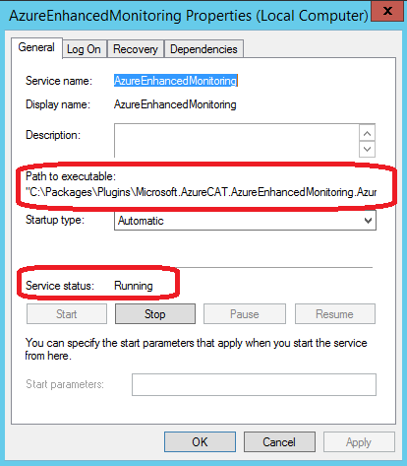
Figure 13 Properties of Service running the Azure Enhanced Monitoring Extension for SAP
- Execute azperflib.exe in the command window without any parameters.
Note: The azperflib.exe runs in a loop and updates the collected counters every 60 seconds.
In order to finish the loop, close the command window.
If the Azure Enhanced Monitoring Extension is not installed or the service ‘AzureEnhancedMonitoring’ is not running, the extension has not been configured correctly. In this case, follow chapter 5.3 for detailed instructions how to redeploy the extension.
Check the output of azperflib.exe
The output of azperflib.exe shows all populated Azure performance counters for SAP. At the bottom of the list of collected counters, you find a summary and a health indicator which indicate the status of the Azure Monitoring.
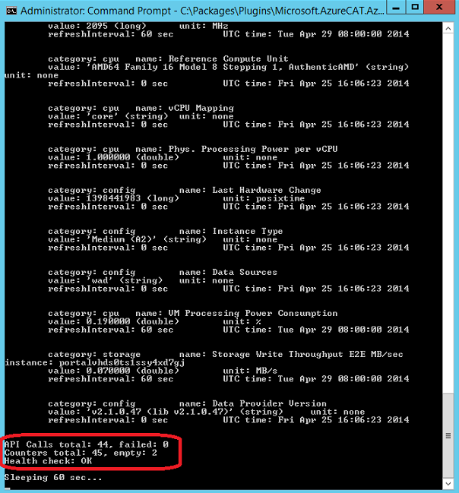
Figure 14 Output of health check by executing azperflib.exe indicating that no problems exist
Check the result returned for the output of the amount of ‘Counters total’ which are reported as empty and for the ‘Health check’ as shown above in Figure 14.
You can interpret the result values as follows:
Azperflib.exe Result Values | Azure Monitoring Readiness Status
Counters total: empty | The following 2 Azure storage counters can be empty:  - Storage Read Op Latency Server msec  - Storage Read Op Latency E2E msec  All other counters must contain values.
Health check | Only OK if return status shows OK

If not both return values of azperflib.exe show that all populated counters are returned correctly, follow the instructions of the Health check for the Azure Monitoring Infrastructure Configuration as described in chapter 5.2 below.

Health check for Azure Monitoring Infrastructure Configuration
If some of the monitoring data is not delivered correctly as indicated by the test described in chapter 5.1 above, execute the Test-VMConfigForSAP_GUI cmdlet to test if the current configuration of the Azure Monitoring infrastructure and the Monitoring extension for SAP is correct.
In order to test the monitoring configuration, please execute the following sequence:
- Make sure that you have installed the latest version of the Microsoft Azure PowerShell cmdlet as described in chapter 4.1 of this document.
- Download and import the PowerShell Module to enable monitoring for SAP Systems as described chapter 4.2 of this document.
- Run the PowerShell cmdlet Test-VMConfigForSAP_GUI. The script will ask for the following input data:
  - Credentials for the Azure subscription,
  - The name of the virtual machine you want to update.
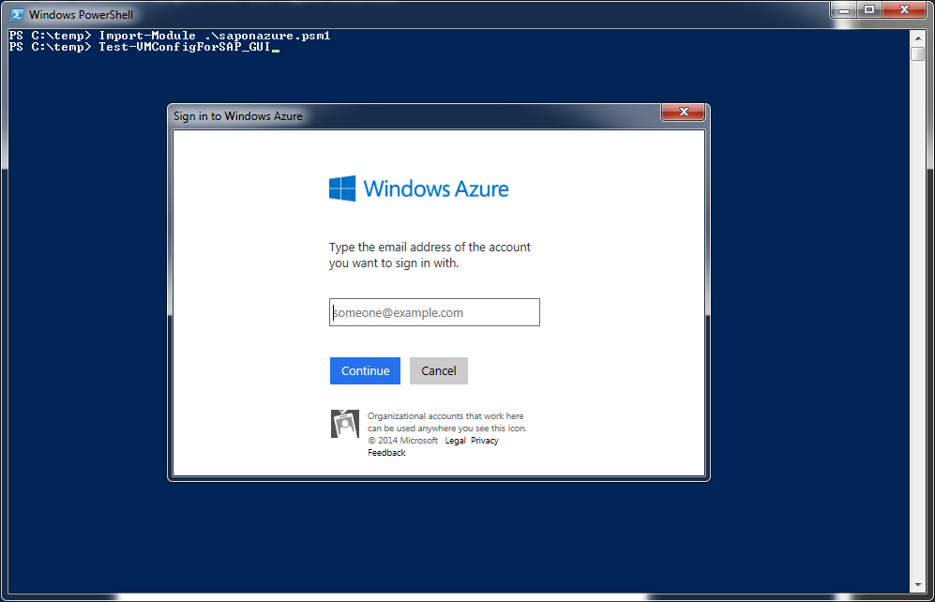
Figure 15 Input screen of SAP specific Azure cmdlet Test-VMConfigForSAP_GUI
After you entered the information about your account and the Azure Virtual Machine, the script will test the configuration of the virtual machine you choose.
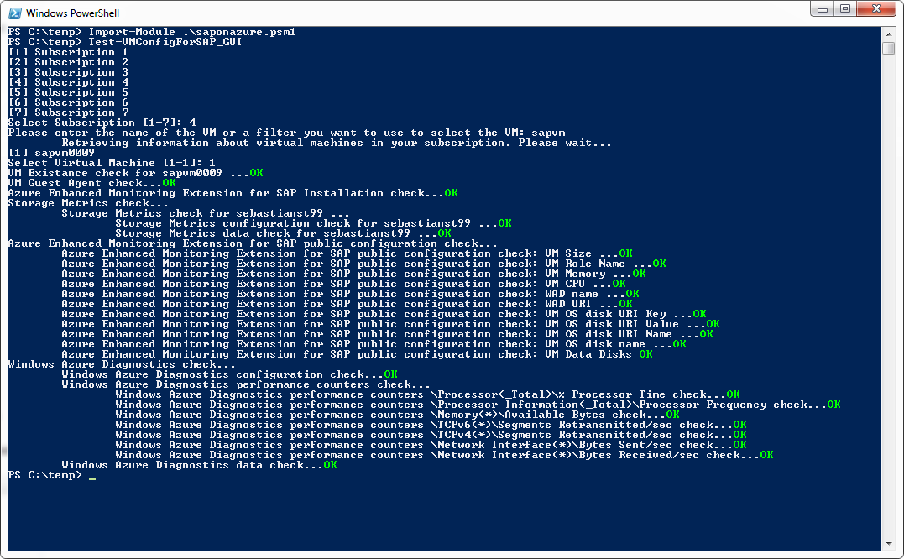
Figure 16 Output of successful test of Azure Monitoring Infrastructure for SAP
Make sure that every check is marked with OK. If some of the checks are not ok, please execute the update cmdlet as described in chapter 4.5 of this document. Wait another 15min and perform the checks described in chapter 5.1 and 5.2 again. If the checks still indicate a problem with some or all counters, please proceed to chapter 5.3.

Further troubleshooting of Azure Monitoring infrastructure for SAP

Azure performance counters do not show up at all
The collection of the performance metrics on Azure is done by the Windows service ‘AzureEnhancedMonitoring’ which is injected in every Azure VM as an extension. If the service has not been installed correctly or if it is not running in your VM, no performance metrics can be collected at all.
The installation directory of the Azure Enhanced Monitoring extension is empty
Issue: The installation directory ‘C:\Packages\Plugins\Microsoft.AzureCAT.AzureEnhancedMonitoring.AzureCATExtensionHandler\<version>\drop’ is empty.
Solution: the extension is not installed. Please check if it is a proxy issue (as described before). You may need to reboot the machine and/or re-run the configuration script Update-VMConfigForSAP_GUI
Service for Azure Enhanced Monitoring does not exist
Issue: Windows service ‘AzureEnhancedMonitoring’ does not exist.
Azperflib.exe: The azperlib.exe output throws an error as shown in Figure 15 below.
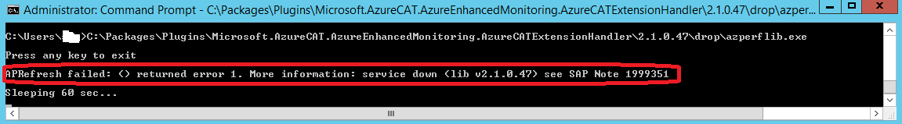
Figure 17 Execution of azperflib.exe indicates that the service of the Azure Enhanced Monitoring Extension for SAP is not running
Solution: If the service does not exist as shown in Figure 17, the Azure Monitoring Extension for SAP has not been installed correctly. Redeploy the extension according to the steps described for your deployment scenario in chapter 3.2 to 3.6 above.
After deployment of the extension, recheck whether the Azure performance counters are provided within the Azure VM after 1 hour or so.
Service for Azure Enhanced Monitoring exists, but fails to start
Issue: Windows service ‘AzureEnhancedMonitoring’ exists and is enabled but fails to start.
Log: Check the application event log for more information.
Solution: Bad configuration. Re-enable the monitoring extension for the VM as described in chapter 4.5.

Some Azure performance counters are missing
The collection of the performance metrics on Azure is done by the Windows service ‘AzureEnhancedMonitoring’ which gets data from several sources. Some configuration data are taken locally, performance metrics are read from Windows Azure Diagnostics and storage counters are used from your logging on storage subscription level.
For a complete and up to date list of known issues please see SAP Note 1999351 – Enhanced Azure Monitoring for SAP containing additional troubleshooting information for the Enhanced Azure Monitoring for SAP.
If troubleshooting using SAP Note 1999351 didn’t help, please re-run the configuration script Update-VMConfigForSAP_GUI. You may have to wait for an hour or so because storage analytics or WAD counters may be created not immediately after they are enabled. If the problem is still there, open an SAP customer support message for the component BC-OP-NT-AZR.

