<Insert your company’s logo here. Apply your company’s branding (fonts, colors, illustration or images) to the rest of the document as desired.>
Office 365
Get more done  Craft compelling content, turn data into insights, and seamlessly collaborate in real time using the Office apps you know and love.  Learn more » |  |  | 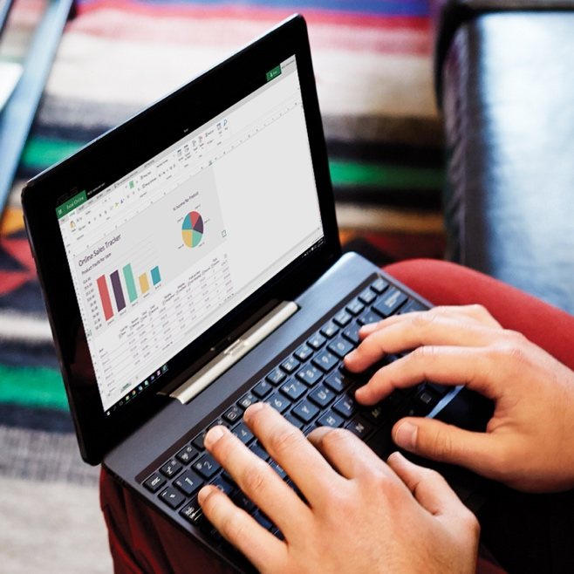
One-click away from real time co-authoring

Share at the click of a button. Use real-time co-authoring in Word, Excel, and PowerPoint apps to work with your colleagues in the same document at the same time, so you can see what others are editing as they type.
Learn more >>
Stunning presentations  in minutes  Use AI-powered tools to create high-quality content that stands out, from impressive slides to animated 3D models and immersive mixed reality experiences.​ Bring presentations to life with PowerPoint Morph and Zoom​. Create stunning slides in a few clicks with PowerPoint Ideas. Share perspective and depth with 3D objects within Office documents​. |  |  |  | 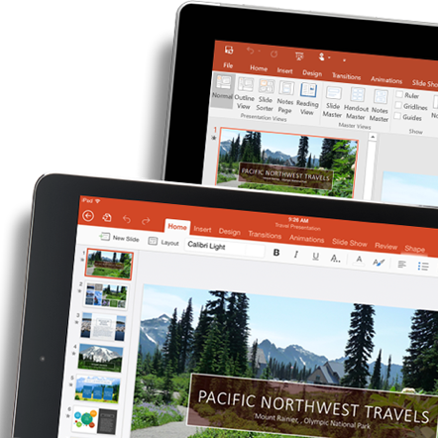
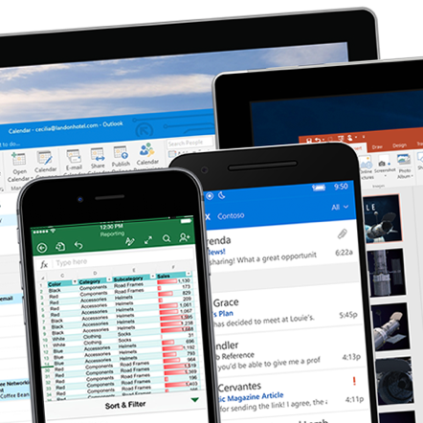 |  | Find what you need, from documents to insights  Focused Inbox helps you concentrate on what matters. Using Tell Me you can simply tell Word, PowerPoint, Outlook, and Excel what you want to do and Tell Me will guide you to the command. Use Excel Ideas to gain insights into your data with auto-generated high-level visual summaries, trends, and patterns.
Work naturally  Go from thought to content effortlessly on any device through more natural ways of working with voice, touch and pen.​ Ideate on a freeform intelligent canvas with Microsoft Whiteboard​. Compose content with your voice using dictation. Sketch, take notes, and annotate with Microsoft Ink. Type faster on touch keyboard with SwiftKey. |  |  |  |  | 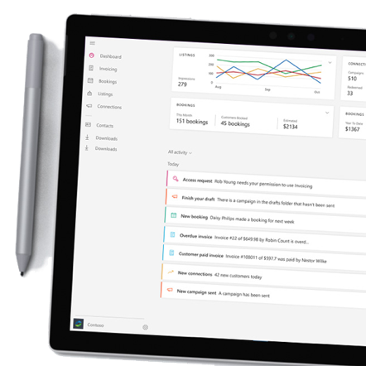
Join us on <fill in date> for tips on getting started with Microsoft Office.
Get started »
 | Share your questions or feedback. We’re here to help you. <Insert email alias or Yammer group link, or customize this section with more information>
Explore training resources
Watch the welcome video »
Explore training resources »
Learn from Office experts »
See scenarios using Office »

