Read Me First: About the
Microsoft Search in Bing Adoption Kit

Introduction
The Microsoft Search in Bing Adoption Kit is designed as a flexible change management program that can be used to increase user awareness, adoption, and engagement. A study conducted by McKinsey showed that organizations with an excellent change management program had an average project ROI of 143% vs 35% ROI without it. (Change Management That Pays,” McKinsey Quarterly, 2002)
The Kit includes planning and preparation guidance, several tools, and templates that can be fully customized. Each of the tools/templates provided in the Kit can be used separately or together as complementary components.

What’s in the Adoption Kit
- Adoption Success Guide – A “first read” that provides next steps and recommended key actions for a successful Microsoft Search in Bing user adoption program.
- Success Guide Checklist – A summary table of key actions and owner assignments.
- Measuring Success Guide – Provides a framework for measuring the impacts of Microsoft Search in Bing to your organization. Includes an example of how to share with Executive sponsors and other key stakeholders via email communications.
- End User Training Presentation Template – An overview training presentation that can be done in-person or webinar format. Users will learn about Microsoft Search features and key search tips they can use right away.
- Executive Communications Planning Guide – Overview presentation for an Executive Sponsor that covers key communications they can send to help drive awareness and adoption within your company.

Communications Tools
- Announcement Email – Introduction to Microsoft Search in Bing for users, plus key resources, training, and support available to help them.
- Executive Announcement Email – A template email your Executive Sponsor can use to help announce the launch of Microsoft Search in Bing to your company.
- Executive Email – Why Microsoft Search in Bing? – Three key talking points to help Champions, Sponsors, and other stakeholders learn about the key benefits for Microsoft Search in Bing.
- Microsoft Search in Bing Tips Emails – Key feature highlights and instructional examples of how to use Microsoft Search in Bing.
- End User Survey Email Template – A feedback tool to use after completion of the adoption program to help collect what users find useful and where there are future opportunities.
- Microsoft Teams and Yammer Posts – Complementary announcement and feature highlight posts that can be shared with users if the customers are actively using these tools in their organization.
- Sample Campaign Calendar – A communications plan for the adoption program that shows a recommended cadence for messaging the user community.
- Posters/Flyer – Companion materials that can be printed and distributed to physical locations across your organization as part of the launch and adoption program. The Kit include a customizable version as well as a print-ready version
- SharePoint Page Template – Recommended content for a resource hub where copies of the tools and materials, training guides, etc., can be stored for users who want to self-service.
- FAQs Document – A template with common user questions intended as a working document that can be appended based on feedback from users in the organization.

Next Steps
- Check that Microsoft Search in Bing is enabled. (It should be—Microsoft Search in Bing is ‘on’ by default for new deployments.)
The easiest way to check that Microsoft Search in Bing has been enabled is to sign into Bing.
- Open a web browser to bing.com on any device and sign in using a work account. It's the same email and password used for Outlook on the web and SharePoint Online. For example, <user@yourcompany.com>.
SIGN IN HERE
- For verification, search for “me.” The search results page should appear like this:
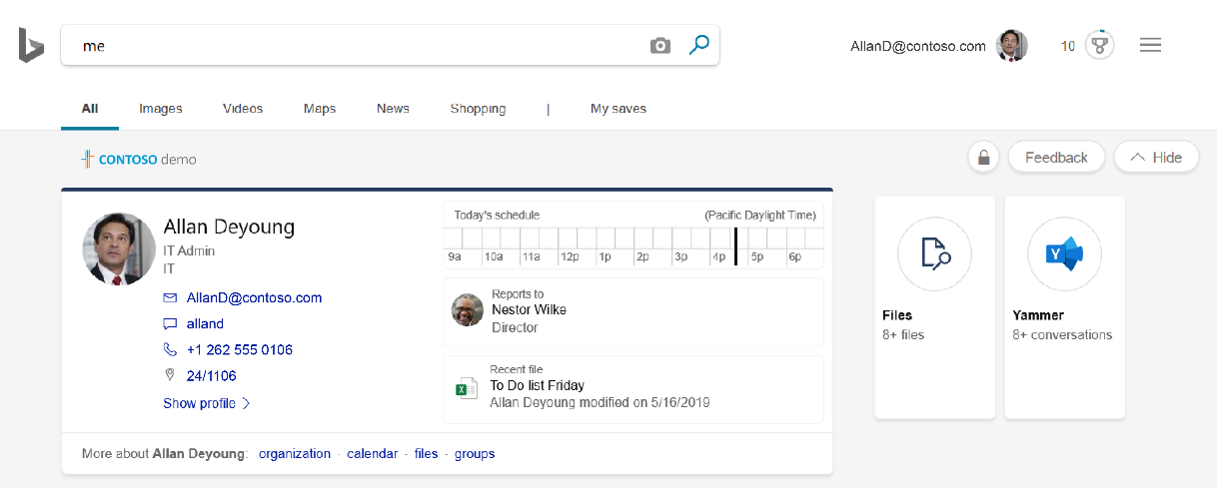
If Microsoft Search in Bing is already enabled, GREAT! Move on to Step 2.

If Microsoft Search in Bing does NOT appear to be enabled, do that now in the Microsoft 365 admin center. Here’s how:
- Go to https://admin.microsoft.com/AdminPortal/Home#/Settings/ServicesAndAddIns
- Scroll down the list of services and add-ins and choose Microsoft Search in Bing
- Click "on" to enable Microsoft Search in Bing
Once enabled, go to Step 2.
If you don’t see it under Settings, check that Microsoft Search is included in your subscription.
- If Microsoft Search is now enabled (or was auto-enabled), you can access its administrative settings at https://admin.microsoft.com/AdminPortal/Home#/MicrosoftSearch or by navigating to Settings > Microsoft Search at admin.microsoft.com. From here, you can start enhancing the user experience by creating bookmarks, Q&As, adding building locations, etc.
- Manage Bookmarks: https://docs.microsoft.com/microsoftsearch/manage-bookmarks
- Manage Q&As: https://docs.microsoft.com/microsoftsearch/manage-qas
- Manage Locations: https://docs.microsoft.com/microsoftsearch/manage-locations
- Additional Customizations: See Settings > Organizational Profile to set a logo, company name, corporate colors, and other settings specific to your organization.
More setup instructions can be found on https://docs.microsoft.com/microsoftsearch/
Users should now be able to sign in to bing.com with a work or school account and get personalized work results when they search.
- Now, get started building the communications plans (executive and end-user programs) and download the Adoption Kit: https://aka.ms/MicrosoftSearch/Adoption. The kit is available in English, German, French, Italian, and Dutch.
- Finally, set Bing as the default search engine in all web browsers to enable easier access for users and to help adoption.

