<Insert your company’s logo here. Apply your company’s branding (fonts, colors, illustration, or images) to the rest of the document as desired. Text in RED below should be modified/customized as needed for your organization. Note: to create links directly to Microsoft Search queries, use:
https://www.bing.com/business/search?q=searchterm1+searchterm2+…>

Subject Line: Microsoft Search in Bing Tip #4: Find the right team or group

Getting your job done often means reaching out to new teams or business groups for information, advice, and collaboration. But how do you find them? Microsoft Search in Bing can help.

Start by signing in with your work account to Microsoft Search in Bing, using any device. Then simply search for the name of the group you’re looking for: <IT Admins, please insert links relevant to your org>

- <Design team>
- <Business development>
- <Human resources>

Your results will show you who owns the group, all the members, and any of the group's files. (Note, if you are not a member of the group you may not be able to view them unless they have been shared outside the group.). If you're a member, you'll see recent Outlook group conversations, as well!

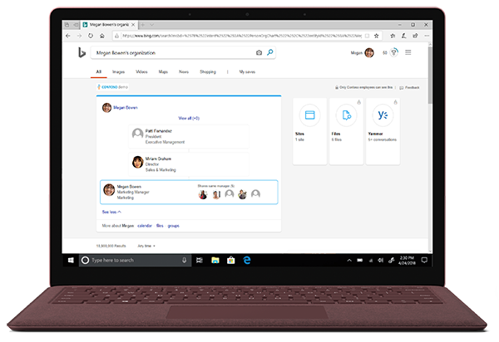

Need to find a group your manager or a co-worker belongs to? Type in their name plus "groups", like this:
- Paul groups

How easy is that? Get your group on with Microsoft Search. See more in this quick video.

Get more information
Learn more about what intelligent search can do to save you time at work on <LINK TO END-USER SharePoint> SharePoint </link>

Join us on <fill in date if you have scheduled training, or delete this line> for more information on getting started with using Microsoft Search in Bing.

We’re here to help you. Share your questions or feedback. <Insert email alias or Yammer group link, or customize this section with more information> Or click the Feedback link in the top-right section of your search results.

Explore training resources
- LINK
- LINK
- LINK

