Congratulations! You’ve successfully announced, integrated, and adopted Microsoft Search in Bing within your organization. As far as you can tell, employees and stakeholders alike are on board.
How do you measure this success? When a curious executive asks about the real-world proof of the productivity-enhancing, timesaving benefits that Microsoft Search in Bing is bringing to your organization—where do you even begin?
Consider this Measuring Success Guide your one-stop shop for steps to identify, measure, and report how effective your launch has been and share impacts that are important to your stakeholders.
Measuring Framework
To showcase success, you need to gather a mix of qualitative and quantitative results that is important to your organization. Evaluate where you are before getting started to establish benchmarks for your organization. Then measure your Key Performance Indicators (KPIs) again after the program has completed to see what changes have occurred.
- Identify business KPIs that you want to target, or the desired outcomes.
For example:
- Adoption: Total users, users trained, daily/weekly/monthly search impressions, bookmark click-throughs, etc.
- Time/cost savings: Example, baseline users time to accomplish common search tasks using existing tools.
- Improved user satisfaction: Track internal Customer Satisfaction scores (CSAT) for your IT department.
Don’t forget about benefits such as cost savings for legacy search technologies (licensing and hardware), call volume reduction to the help desk, etc.
- Take baseline measurements and track progress so you can share the results
Collect data for your KPIs at launch, as well as, after the completion of all change management activities to see the overall impacts to your organization. Also, consider one or more measurement points during the rollout program—interim results can provide insight on progress towards the KPI goals and allow time for changes if need be to ensure your targets will be met or exceeded.
For usage and adoption-related KPIs, you can get several metrics from the Microsoft 365 admin center to track behavioral change within your organization, including:
- Top Queries and Impressions by search result type (Bookmarks, Files, Q&As, People, Groups, Sites, Locations, Conversations)
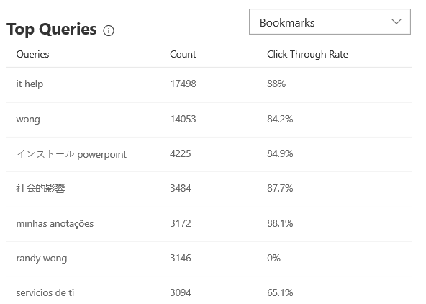
See what searches have generated the most impressions over the last 90 days. If popular search queries are not yet Bookmarks, doing so will save users even more time. The top 25 user searches for each result type are shown along with the total number of impressions and their click-through rate (CTR).
- Impressions by result type.
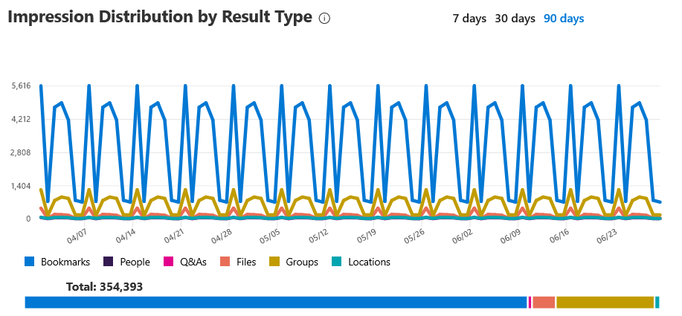
Easy-to-read graphs in the Impression Distribution by Result Type card show data over various time frames, enabling you to identify where (and how) your users are searching. The summary shows the number of impressions with a percentage calculation for the distribution (number of result type impressions x 100 / total number of impressions).
The timeline shows the daily number of impressions for a result type.
You can also change the time range for both views and get more details:
- On the top of the card, click 7 days, 30 days, or 90 days.
- Hover on a data point of the line for impressions by result type for a single day.

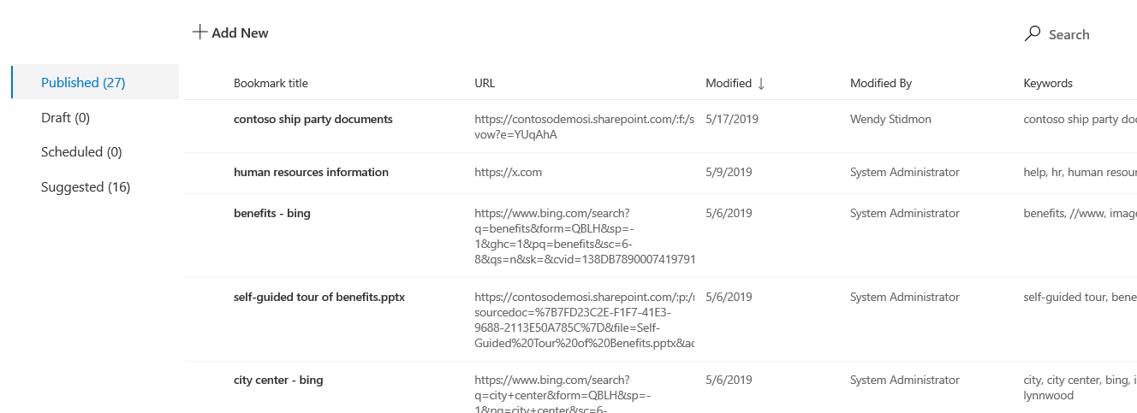
- Bookmarks, Q&As, and Locations that have been published, drafted, scheduled, or suggested.
Use the dashboard to see bookmark or Q&A totals by status. Doing so highlights what your users are finding most helpful (as well as pinpoints ways to save them even more time while they search).
Go to Microsoft 365 admin center > Settings > Microsoft Search to view insights for your organization.
- Define the goals you plan to achieve.
For example:
- Adoption: achieve X% Microsoft Search in Bing users of total paid Microsoft 365/Office 365 licenses monthly, increase the number of Microsoft Search in Bing users per month from X to Y, etc.
- Time/Cost Savings: Reduce time to find Y by - X minutes, - Y $ (time) saved per employee, -Y $ hardware/licensing cost reduction.
- Improved satisfaction: +X points (or %) average CSAT increase post-deployment/adoption.

- Identify success stories and gather quotes, interviews, roundtables, Yammer groups, etc.
Real workplace impacts are a great way to highlight the results of your team's hard work in planning, preparing, and rolling out solutions like Microsoft Search in Bing.
- Share regular updates and key successes about the impact of your work and the ROI Microsoft Search in Bing is having on your organization.

Below, find an email template that you can use to send updates to your executives, stakeholders, and community, informing them of the specific and immediate effects.

<Insert your company’s logo here. Apply your company’s branding (fonts, colors, illustration, or images) to the rest of the document as desired. Text in RED below should be modified/customized as needed for your organization; the screenshot can also be replaced with one from your organization.>
Subject Line: UPDATE: Microsoft Search is saving us time, effort, and hassle. Here’s how
Hello,
It’s been [number of days/weeks/months] since we officially adopted Microsoft Search within our organization—here’s how we’ve been doing:
Our bookmark or Q&A totals:
- Published: [Number of published results that are available to users]
- Scheduled: [Number of scheduled results in the publish pipeline]
- Suggested: [Number of suggestions from users]
Our most popular search queries:
These searches have generated the most impressions over the last 90 days: [list]
Key impressions to see:
This summary shows the number of impressions with a percentage calculation for the distribution (number of result type impressions x 100 / total number of impressions).
[insert screenshot of key insights from the impression distribution chart]
Optional Section:
Adoption strategies:
Approximately [x] % of our users have used Microsoft Search in Bing one or more times in the last [x]
To increase usage, we are [insert strategy summary]
ROI implications:
Total savings:
Total cost cuts:
Look for more updates as we continue to move forward with the many benefits of Microsoft Search.

Have a great day.

