<Insert your company’s logo here. Apply your company’s branding (fonts, colors, illustration, or images) to the rest of the document as desired. Text in RED below should be modified/customized as needed for your organization. Note: to create links directly to Microsoft Search queries, use:
https://www.bing.com/business/search?q=searchterm1+searchterm2+…>

Email Subject Line: Microsoft Search in Bing Tip #2: Find people in our company quickly

Have you ever met someone in a meeting but didn’t catch their last name? Or want to find out what team they’re on and who they report to? With Microsoft Search in Bing, you can quickly find lots of helpful information about people in our company.

Start with a name
On any device, go to Bing.com and sign in with your work account, like <user@company.com>. In the search box, enter the person's full name. Don’t know it? Type in what you know – a first name or their email – and Microsoft Search will show you the result that best matches your search:

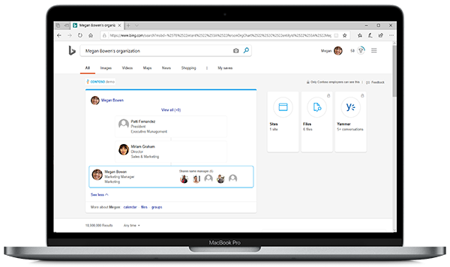

Get intelligent results
When you search for someone, at the top of their page you get their contact information, plus:
- Their schedule: <Paul schedule>
- Files that they’ve previously shared with you: <Paul files>
- Their org chart: <Paul org>

Along with work results you’ll see web results for your search, all on the same page.

Find yourself!
Type in your name or use Me or My Org. And remember, only people within our organization will see these results, as long as they are signed in.

Learn more in this video, then give it a try.

Get more information
Learn more about what intelligent search can do to save you time at work on <LINK TO END-USER SharePoint> SharePoint </link>

Join us on <fill in date if you have scheduled training, or delete this line> for more information on getting started with using Microsoft Search in Bing.

We’re here to help you. Share your questions or feedback. <Insert email alias or Yammer group link, or customize this section with more information> Or click the Feedback link in the top-right section of your search results.

Explore training resources
- LINK
- LINK
- LINK

