<Insert your company’s logo here. Apply your company’s branding (fonts, colors, illustration or images) to the rest of the document as desired.>
Welcome to your new Office
With Office, you can get things done from virtually anywhere. You can access, share, and co-author documents with Office integrating with OneDrive for Business and SharePoint. You can also download the Office Mobile apps to help you access everything you need to work seamlessly from nearly any device while you’re on the move. |  |  | 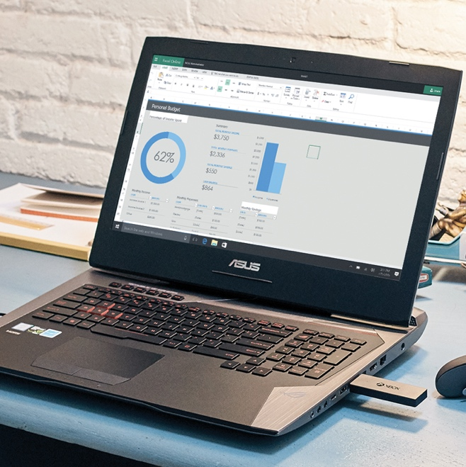
The new Office enables you to:
• Work collaboratively with your group across all your devices
• Work with the very latest version of your documents. All the time
• Work from the very latest versions of: Word, Excel, PowerPoint, Outlook, OneNote, Sway, and Publisher
Join the network
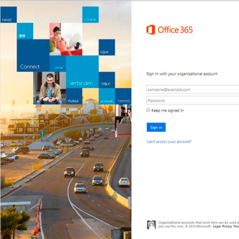 |  |  |  | 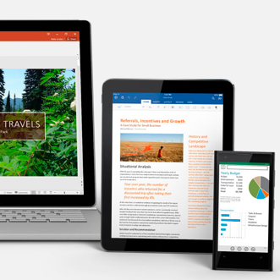
Sign into Office |  | Set up Office on your devices |  | Start to create,  share, and collaborate
Join us on <fill in date> for tips on getting started with
Microsoft Office.
Get started »
Share your questions or feedback.
<insert email alias or Yammer group link for company>
Explore training resources
See what you can do with Office »
Watch the welcome video »
Explore training resources »
Learn from Office experts »
See scenarios using Office »

