Azure Active Directory B2B Collaboration - Adoption Kit
Contents
Azure Active Directory B2B Collaboration - Adoption Kit 1
Awareness 3
Business Overview 3
Pricing and Licensing Requirements 3
Key Benefits 4
Customer stories/Case studies 4
Announcements/Blogs 5
Training 5
Level 100 Knowledge/Concepts 5
Role-Based Guidance 6
IT Administrator Staff 6
Help Desk Staff 6
Training 6
On-Demand Webinars 6
Videos 6
Online Courses 7
Tutorials 7
Whitepaper 7
FAQ 7
End-User Readiness and Communication 7
Planning and Change Management 8
Deployment Plan 8
Prerequisites 8
Architecture Plan/Topology 8
Testing 8
Deployment 9
Readiness Checklist 9
Design Template 9
Operations 9
Operations 9
Monitoring 10
Troubleshooting 10
References 10
Support and Feedback 10

Awareness
This section helps you to analyze the benefits of Azure Active Directory (Azure AD) Business-to-Business. You will learn about the ease of use, pricing and licensing model, as well as customer stories about how it helped improve their business. You will also receive up-to-date announcements and access to blogs that discuss ongoing improvements.

Business Overview
In addition to managing their employees and mobile workforce access the required SaaS and (cloud-based, hybrid, and on-premises) corporate Line-Of-Business (LOB) applications, Azure AD can help organizations manage their external users, and thus notably share resources with business partners and deliver applications to business.
Azure AD Business-to-Business (B2B) Collaboration supports your cross-company relationships by enabling partners to selectively access your corporate applications and data using their identities. You can work safely and securely with external partners, large or small, even if they do not have Azure AD or an IT department. A simple invitation and redemption process let partners use their own credentials to access your company's resources.
- Simple. Each partner uses an existing Azure AD account or one that you can easily create and provide this user with access to corporate applications you choose. The partner user then exists in your Azure AD as an external user. Then your IT professionals can provision licenses, assign group membership, and further grant access to corporate applications through the Azure portal or PowerShell as they do for users within your organizations.
- Secure. Your IT professionals control all access to your corporate applications through your Azure AD. When collaboration is terminated, partner users can be removed from your Azure AD and their access to your applications is immediately canceled.
See What is guest user access in Azure Active Directory B2B?
Both Azure Active Directory (Azure AD) B2B collaboration and Azure AD B2C allow you to work with external users in Azure AD. But how do they compare? See Compare B2B collaboration and B2C in Azure Active Directory

Pricing and Licensing Requirements
Azure AD allows for B2B collaboration by enabling the use of a select set of Azure AD features to guest users who are invited into the Azure AD tenant. While some features are free, for any paid Azure AD features, guest users must be licensed. With each Azure AD edition license owned for an employee or a non-guest user in your tenant, you can invite up to 5 guest users to the tenant. The features extended to these guest users depend on the type of Azure AD edition.
For more information, refer to the following links:
- Azure Active Directory B2B collaboration licensing guidance
- Azure Active Directory pricing

Key Benefits
Here are the key benefits of using Azure AD B2B Collaboration:
Seamless, highly secure access
Connect your users with the apps they need with a seamless experience across cloud, mobile and on-premises apps.
Comprehensive identity protection
Protect user accounts and increase security with conditional access and ongoing threat detection and response.
Efficient management and compliance at scale
Stay in control and reduce costs using automation, self-service, and policy enforcement.
Customer and partner identities
Connect and collaborate with your customers and partners easily and more securely without extra overhead.

Customer stories/Case studies
Discover how most organizations are coming together using Azure AD B2B Collaboration. The following featured stories demonstrate this scenario:
Aramex - Global logistics and transportation company creates cloud-connected office with identity and access management solution Aramex uses B2B collaboration capabilities that allows its remote employees, customers, and contractors to access SaaS applications, and provides a secured improved user experience.
BDO:- Leading global accounting, tax and advisory organization scales global IT services with Microsoft With new B2B capabilities in Azure AD, BDO firms can share documents, resources, and applications with one another while maintaining full control over their own valuable data.
Hearst Corporation: Eight things this media giant likes about Microsoft Enterprise Mobility + Security and Azure Active Directory Hearst uses Azure AD B2B collaboration services to give users in acquired business units a quick access to Hearst network resources.
To learn more about customer and partner experiences on Azure B2B collaboration, visit - See the amazing things people are doing with Azure.

Announcements/Blogs
Azure AD receives improvements on an ongoing basis. To stay up to date with the most recent developments, see What's new in Azure Active Directory?.
Recent blogs by the Tech Community and Microsoft Identity Division:
- January 28, 2019, Azure AD makes sharing and collaboration seamless for any user with any account
- December 06, 2018 Azure AD Ignite 2018 Recap 2: External Identities (B2B and B2C)
- September 07, 2018, Improving the branding logic of Azure AD login pages
- September 07, 2018, Exciting improvements to the B2B collaboration experience
- April 26, 2018, Azure AD B2B collaboration for hybrid organizations

Training
The section provides concepts, role-based guidance, and lists the various training resources available on Azure AD B2B Collaboration.

Level 100 Knowledge/Concepts
Learn how to use Azure AD business-to-business (B2B) collaboration to securely share your company's applications and services with guest users and external partner users from any organization, while maintaining control over your own corporate data. Here are some of the key features:
- Through a simple invitation and redemption process, guest users can start collaborating on the resources you want them to access.
- Your guest users and external partners manage their own identities through Azure AD, social email accounts, or any identity provider.
- You can protect your corporate resources with Azure AD features like multi-factor authentication.
- You can use API’s to customize the experience, for example through a self-service sign-up portal.
Refer to the following links to help you get started:
- Learn what is guest user access in Azure Active Directory B2B?
- Watch this video - Azure Active Directory B2B Collaboration: simple, secure external sharing of your Apps and Services
- Get Azure Active Directory B2B collaboration licensing guidance
- Compare B2B collaboration and B2C in Azure Active Directory
- The difference in between Office 365 external sharing and Azure Active Directory B2B collaboration
- How do you use the Azure Active Directory B2B collaboration invitation redemption?
- The elements of the B2B collaboration invitation email for a guest user
- Properties of an Azure Active Directory B2B collaboration user
- How the B2B collaboration user claims mapping in Azure Active Directory?
- Understand user tokens in Azure AD B2B collaboration
- Understand conditional access for B2B collaboration users
- What is Azure Active Directory B2B collaboration for hybrid organizations?
- What are the limitations of Azure AD B2B collaboration?

Role-Based Guidance

IT Administrator Staff
As a global administrator, or a user who is assigned any of the limited administrative directory roles, you can use the Azure portal to invite B2B collaboration users. You can invite guest users to the directory, to a group, or to an application. After you invite a user through any of these methods, the invited user's account is added to Azure Active Directory (Azure AD), with a user type of “Guest”. The guest user must then redeem their invitation to access resources. Refer to the “Getting Started with Azure AD B2B Collaboration” section in the Introduce Azure AD B2B Collaboration document.
Additionally, refer to the following links:
- Quickstart: Add guest users to your directory in the Azure portal
- Quickstart: Add a guest user with PowerShell
- How to add Azure Active Directory B2B collaboration users in the Azure portal?
- The elements of the B2B collaboration invitation email for a guest user.
- Grant permissions to users from partner organizations in your Azure Active Directory tenant
- What are the properties of an Azure Active Directory B2B collaboration user?
- How to add B2B collaboration guest users without an invitation link or email?
- How to add branding to your organization's Azure Active Directory sign-in page?

Help Desk Staff
- See Getting support for B2B collaboration
- Search Azure Active Directory B2B collaboration FAQs
- Search for and browse technical questions and answers from the community, or ask your own question in the Azure Active Directory Forum.

Training

On-Demand Webinars
Reserve here – Manage Partner and Vendor Access Using Azure B2B Collaboration

Videos
- YouTube - Azure AD B2B Collaboration: simple, secure external sharing of your Apps and Services
- Azure videos - B2B Collaboration on Windows Azure
- Azure videos - Azure Active Directory B2B collaboration demo
- Azure videos - Setup Azure Active Directory B2B collaboration for simplified resource sharing with external users

Online Courses
- PluralSight- Design Identity Management in Microsoft Azure
“In this course, you will gain the foundation knowledge necessary to utilize Azure AD to enable a highly secure identity that can be leveraged across your organization’s services and those applications provided externally.” Azure AD B2B Collaboration is covered in “Azure AD Overview” module.
- PluralSight- Design Authentication for Microsoft Azure
“This course will explain how to leverage Azure AD to solve all your cloud authentication requirements.” Azure AD B2B Collaboration is covered in “Authentication Requirements for Different Scenarios” module.
- LinkedIn Learning- Azure-tutorials: Implement-B2B-collaboration
“In this course, learn how to integrate Azure AD with existing directories, configure the application access panel, and implement AD for B2C and B2B.”

Tutorials
Learn more about setting up B2B collaboration and securing your company's resources.
- Tutorial: Bulk invite Azure AD B2B collaboration users
- Tutorial: Enforce Multi-Factor Authentication for B2B guest users
Learn how to invite guest users and get started with B2B collaboration.
- Quickstart: Add a guest user with PowerShell
- Quickstart: Add guest users to your directory in the Azure portal

Whitepaper
Published Mar 06, 2019, Distribute Power BI content to external guest users using Azure Active Directory B2B.
This is a technical whitepaper outlining how to distribute content to users outside the organization using the integration of Azure Active Directory Business-to-business (Azure AD B2B).

FAQ
Refer to Azure Active Directory B2B collaboration FAQs on common questions on using the B2B service.

End-User Readiness and Communication
This section provides customizable posters and email templates to roll out Azure AD B2B Collaboration to your guest users.
Invitation emails are a critical component to bring partners on board as B2B collaboration users in Azure AD. You can use them to increase the recipient's trust. You can add legitimacy and social proof to the email, to make sure the recipient feels comfortable with selecting the Get Started button to accept the invitation and you also want to make the email look great! See The elements of the B2B collaboration invitation email - Azure Active Directory.

Planning and Change Management
This section provides the resource links to Azure AD B2B Collaboration deployment plan and topology to help you determine your B2B strategies, and document your decisions and configurations to prepare for implementation.

Deployment Plan
Refer to “Supporting B2B collaboration scenarios” section in the Introduce Azure AD B2B Collaboration document.

Prerequisites
In order to successfully deploy Azure AD B2B collaboration between your organization, and your guest organization- you require two distinct Azure AD directory tenants: one for your organization, and another one for your guest organization. Refer to “Appendix A. Building a test lab environment” in the Introduce Azure AD B2B Collaboration document to make sure that the environment reflects the prerequisites.

Architecture Plan/Topology
How does Azure B2B Collaboration work?
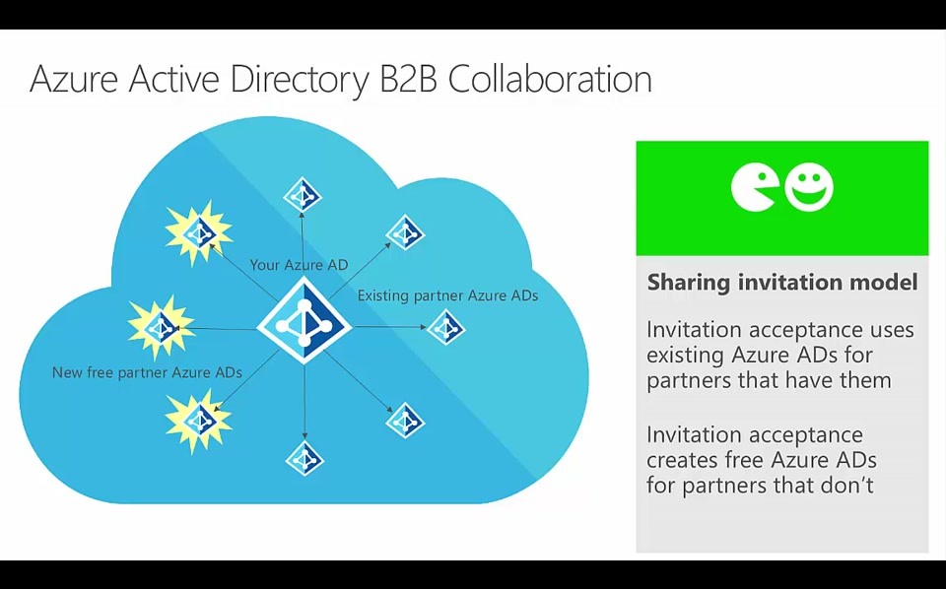

Testing
This section provides the plan to test the functionality of Azure AD B2B Collaboration in a sandbox or test lab environment before the customer rolls it into production.
Refer to “Appendix A. Building a test lab environment” in the Introduce Azure AD B2B Collaboration document.

Deployment
This section provides resource links to help with deployment and implementation of your solution.

Deployment
Learn more about setting up B2B collaboration and securing your company's resources.
- Tutorial: Bulk invite Azure AD B2B collaboration users
- Tutorial: Enforce multi-factor authentication for B2B guest users
Refer to “Getting Started with Azure AD B2B collaboration” section in the Introduce Azure AD B2B Collaboration document.
You can also refer to the following links:
Manage Invitations
- Add Azure Active Directory B2B collaboration users in the Azure portal?
- How users in your organization can invite guest users to an app?
- Email one-time passcode authentication (preview)?
- Delegate invitations for Azure Active Directory B2B collaboration
- Allow or block invitations to B2B users from specific organizations
- Add B2B collaboration guest users without an invitation
- Azure Active Directory B2B collaboration API and customization
Manage Guest Accounts
- Grant permissions to users from partner organizations in your Azure AD tenant
- Dynamic groups and Azure Active Directory B2B collaboration
- Properties of an Azure Active Directory B2B collaboration user
- Configure SaaS apps for B2B collaboration?
Manage Access in Hybrid Organization
Leave an organization as a guest user

Operations
This section provides the Azure AD B2B Collaboration operation and management details, troubleshooting info, and other important references.

Operations
Learn how to invite, manage, or remove guest users. Refer to the following links:
- Quickstart: Add a guest user with PowerShell
- Quickstart: Add guest users to your directory in the Azure portal
- Grant locally managed partner accounts access to cloud resources using Azure AD B2B collaboration
- Grant B2B users in Azure AD access to your on-premises applications
- Guest user account removal
You can also refer to “Getting Started with Azure AD B2B collaboration” section in the Introduce Azure AD B2B Collaboration document.

Monitoring
With guest users, you have auditing capabilities like the member users. Refer to the following links:
- Manage guest access with Azure AD access reviews
- Auditing and reporting a B2B collaboration user

Troubleshooting
Refer to the following links to troubleshoot common problems with Azure AD B2B collaboration:
- Troubleshooting Azure Active Directory B2B collaboration
- Follow Azure Active Directory B2B collaboration FAQs

References
Here are some additional links to refer to:
- Your customers can customize the invitation process in a way that works best for their organizations. See Azure Active Directory B2B collaboration API and customization.
- You can bulk-invite external users to an organization from email addresses that you have stored in a .CSV file. See Azure Active Directory B2B collaboration code and PowerShell samples
- Customers can do a lot with the built-in features that are exposed through the Azure portal and the Application Access Panel for end users. However, you might need to customize the onboarding workflow for B2B users to fit your organization’s needs. See Self-service portal for Azure AD B2B collaboration sign-up

Support and Feedback
How can we improve Azure AD B2B Collaboration? This section provides links to discussion forums and technical community support email IDs.
We encourage you to join our Technical Community, a platform to Microsoft Azure Active Directory users and Microsoft to interact. It is a central destination for education and thought leadership on best practices, product news, live events, and roadmap.
If you have technical questions or need help with Azure, please try StackOverflow or visit the MSDN Azure AD forums.
Tell us what you think of Azure and what you want to see in the future. If you have suggestions, please submit an idea or vote up an idea at our User Voice Channel - feedback.azure.com.

