<Insert your company’s logo here. Apply your company’s branding (fonts, colors, illustration or images) to the rest of the document as desired.>
Office 365
Get more done  Craft compelling content, turn data into insights, and seamlessly collaborate in real time using the Office apps you know and love.  Learn more » |  |  | 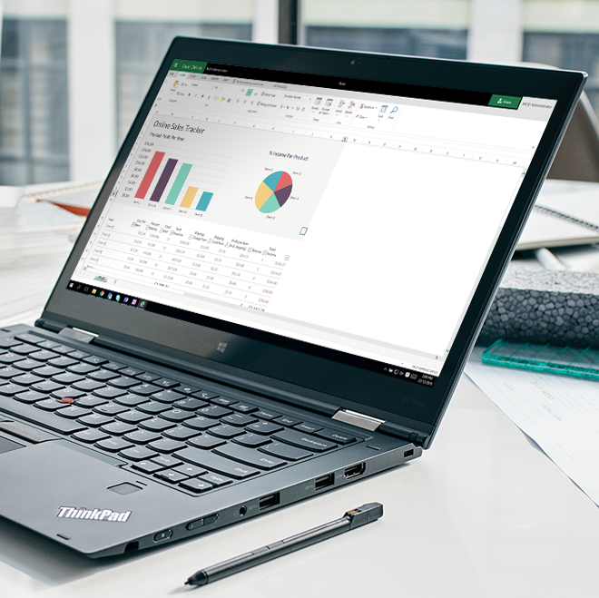
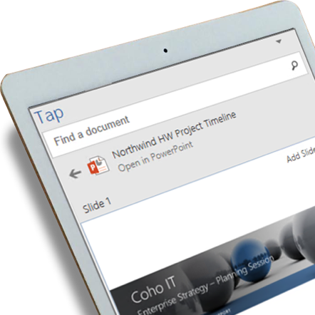 |  | Create content that stands out​  Use AI-powered tools to create high-quality content that stands out, from impressive slides to animated 3D models and immersive mixed reality experiences.​ Bring presentations to life with PowerPoint Morph and Zoom​. Create stunning slides in a few clicks with PowerPoint Ideas​. Share perspective and depth with 3D objects within Office documents​.
Co-author documents  with your group  Real-time co-authoring in your desktop Word, Excel, and PowerPoint apps lets you and your colleagues all edit the same document at the same time, so you can see what others are editing as they type.  Learn more >> |  |  |  | 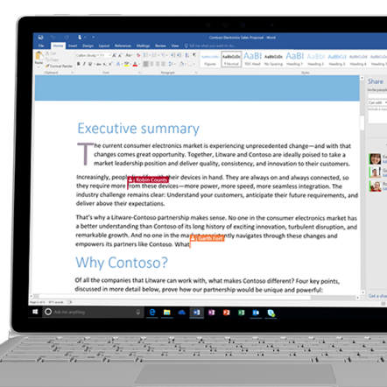
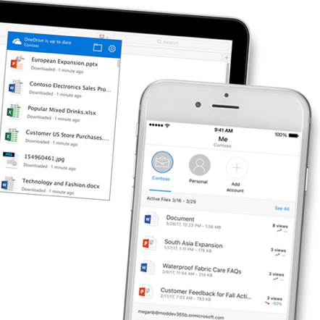 |  | Access your files  on all your devices  You're out of the office and need an important file. With OneDrive for Business, you can open and edit Office files across your devices using Office apps or a browser. Your work will save automatically. If you work offline, changes will synchronize to OneDrive for Business as soon as you reconnect.  Get the mobile apps for iOS or Android here >>
Discover people  You can view someone’s profile page simply by clicking on their name in Delve. On a profile page, you see information about them and what documents they're working on. You also see people they're connected to, and popular documents from people around them. |  |  |  | 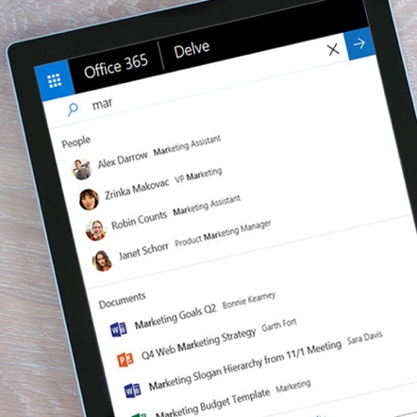
Join us on <fill in date> for tips on getting started with Microsoft Office.
Get started »
 | Share your questions or feedback. We’re here to help you. <Insert email alias or Yammer group link, or customize this section with more information>
Explore training resources
Watch the welcome video »
Explore training resources »
Learn from Office experts »
See scenarios using Office »

