<Insert your company’s logo here. Apply your company’s branding (fonts, colors, illustration or images) to the rest of the document as desired.>
It’s the Office you know – but better

On <fill in date> we're rolling out Office 365 ProPlus, the most productive and secure version of Office. Whether you work on a PC, Mac, tablet, or phone, you will have a consistent experience across all your devices with the familiar apps you are used to.  See it in action » |  |  | 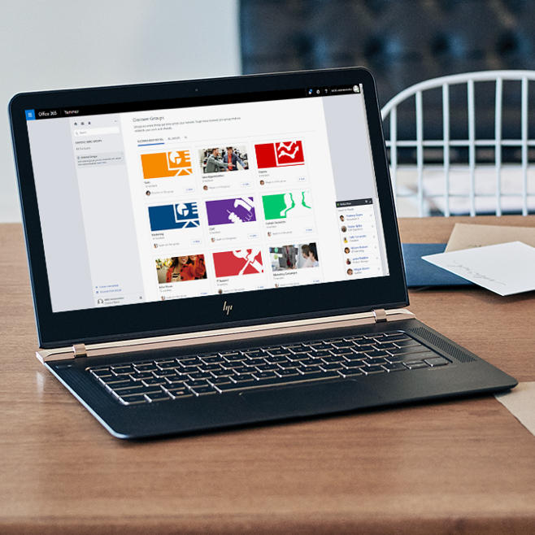
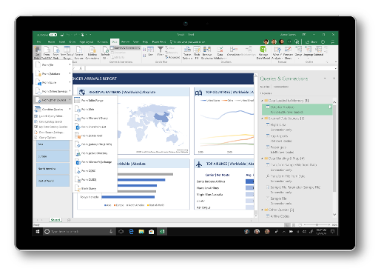 |  | Share and collaborate with confidence  With the apps in Office 365 ProPlus, you can easily share and collaborate on documents, while version history lets you track changes. And with Artificial Intelligence built in, you have a world of assistance and data from the Office 365 cloud at your fingertips.
Pick up right where  you left off  Office 365 ProPlus helps you work effortlessly across all your devices. It can show you what’s been shared with you, and remembers where you left off in your documents, so you can make the best use of your time. And it makes your personalized experience follow, wherever you go. |  |  |  | 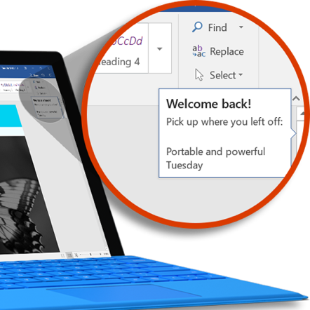
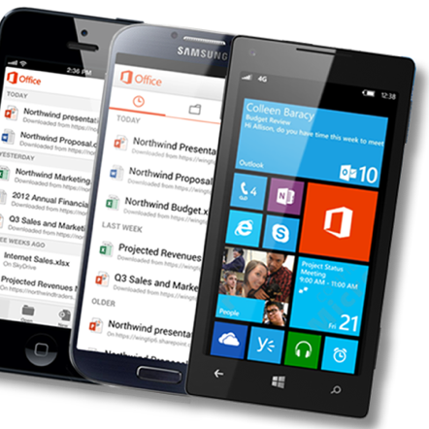 |  | Portable productivity  with apps  With full-fidelity Office mobile apps for Android™, iOS™, and Windows™ devices, you get the familiar Office experience optimized for touch and smaller screens for all your devices. You can also create and edit your documents offline – no internet connection is needed.
Join us on <fill in date> for tips on getting started with Microsoft Office.
Get started »
 | Share your questions or feedback. We’re here to help you. <Insert email alias or Yammer group link, or customize this section with more information>
Explore training resources
See what you can do with Office »
Watch the welcome video »
Explore training resources »
Learn from Office experts »
See scenarios using Office »

