Azure Active Directory Company Branding- Adoption Kit
Contents
Azure Active Directory Company Branding- Adoption Kit 1
Awareness 2
Business Overview 2
Pricing and Licensing Requirements 2
Key Benefits 2
Customer stories/Case studies 3
Announcements/Blogs 3
Training/Learning Resources 3
Level 100 Knowledge/Concepts 3
Role-Based Guidance 3
IT Administrator Staff 3
Help Desk Staff 3
Training 4
Videos 4
Marketplace 4
Online Courses 4
Books 4
Tutorials 4
End-user Readiness and Communication 4
Planning and Change Management 5
Deployment Plan 5
Testing 5
Deployment 5
Operations 5
Monitoring 5
Support and Feedback 5

Awareness
This section helps you to analyze the benefits of Azure Active Directory (Azure AD) Company Branding. You will learn about the ease of use, pricing, and licensing model, as well as customer stories about how it helped improved their business. You will also receive up-to-date announcements and access to blogs that discuss ongoing improvements.

Business Overview
Organizations today want to apply a consistent look and feel across all the websites and services they manage. Azure AD provides the Company Branding capability by allowing the companies to customize the appearance of the access web pages with a company logo and custom color schemes.
With Azure AD Company Branding you can:
- Customize your Azure AD sign-in page
- Update your custom branding
- Add language-specific company branding to your directory
- Add your custom branding to pages

Pricing and Licensing Requirements
Company branding capability requires you to use Azure Active Directory Premium P1, Premium P2. For more information about licensing and editions, see Sign up for Azure Active Directory Premium editions.
For more information on pricing, refer to Azure Active Directory pricing.

Key Benefits
The key benefits of using Azure AD Company Branding are:
Consistent view
Your users get a consistent look and feel across all the websites and services you manage.
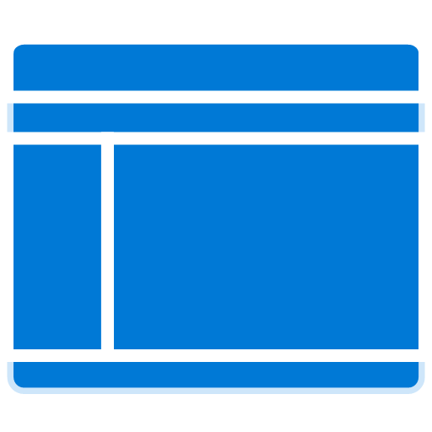 | Custom branding  You can customize the sign-in page to show your company brand, colors, and other customizable elements.
Better user experience
Company branding improves your user’s experience while keeping the corporate brand and image intact.

Manage Security
Company branding ensures that you are on the right page, which will give users a secure indication when they sign-in.

Customer stories/Case studies
Learn about customer and partner experiences on Azure AD Company Branding - See the amazing things people are doing with Azure.

Announcements/Blogs
Azure AD receives improvements on an ongoing basis. To stay up to date with the most recent developments, see What's new in Azure Active Directory?.
Blogs by the Tech Community and Microsoft Identity Division:
- September 07, 2018, Improving the branding logic of Azure AD login pages
- October 05, 2018, Branding enhancements

Training/Learning Resources
The section provides concepts, role-based guidance, and lists the various training resources available on Azure AD Company Branding.

Level 100 Knowledge/Concepts
Refer to the following topics:
- How do you Add branding to your organization's Azure Active Directory sign-in page?
- What are the ways to Sign up for Azure Active Directory Premium editions?
- What are the Branding guidelines for applications?

Role-Based Guidance

IT Administrator Staff
Refer to the following topics:
- Sign up for Azure Active Directory Premium editions
- Add branding to your organization's Azure Active Directory sign-in page

Help Desk Staff
- Search the Microsoft Support Knowledge Base for solutions to common technical issues.
- Search for and browse technical questions and answers from the community, or ask questions in the Azure Active Directory forums.

Training

Videos
- LinkedIn Learning – Add company branding and a custom domain to Azure AD
- LinkedIn Learning - Brand the login environment for Azure Active Directory users
- Youtube – Azure Active Directory – Company Branding

Marketplace
- Azure AD Company Branding Marketplace
- Azure AD Company Branding Consulting Services

Online Courses
- PluralSight.com - Getting Started with the Microsoft Enterprise Mobility Suite
“This course will provide best practices that you need to know for extending on-premises assets to the cloud in a manner that allows for authentication, authorization, encryption, and a secured mobile experience.” Company branding is discussed in “Configuring Advanced Features of Microsoft Azure Active Directory Premium” module.
- PluralSight.com - Microsoft Hybrid Identity – Overview
“Learn how to safely offer cloud apps to your users and on-premises apps to cloud users.” Refer to “Configuring Self-Service and Branding” in “Managing Your Hybrid Identity” module.

Books
Oreilly.com: Mastering Identity and Access Management with Microsoft Azure by Jochen Nickel
“Start empowering users and protecting corporate data, while managing identities and access with Microsoft Azure in different environments.” Company branding is covered in “Building and Configuring a Suitable Azure AD” chapter.

Tutorials
Use your organization's logo and custom color schemes to provide a consistent look-and-feel on your Azure Active Directory (Azure AD) sign-in pages. See Add branding to your organization's Azure Active Directory sign-in page.

End-user Readiness and Communication
This section provides customizable posters and email templates to roll out Azure AD Company Branding to your organization.
Refer to Add branding to your organization's Azure Active Directory sign-in page

Planning and Change Management
This section provides the resource links to Azure AD Company Branding deployment plan and topology to help you determine your Company Branding strategies, and document your decisions and configurations to prepare for implementation.

Deployment Plan
Refer to Add branding to your organization's Azure Active Directory sign-in page.

Testing
This section provides the plan to test the functionality of Azure AD Company Branding in a sandbox or test lab environment before the customer rolls it into production.
Refer to Add branding to your organization's Azure Active Directory sign-in page.

Deployment
How can I get Azure AD Company Branding deployed in my environment? This section provides resource links to help with implementation of your solution.
Refer to Add branding to your organization's Azure Active Directory sign-in page.

Operations
How do I manage and maintain Azure AD Company Branding? This section provides troubleshooting info, Azure AD User Provisioning operation and management details, and other important references.

Monitoring
Refer to Add branding to your organization's Azure Active Directory sign-in page.

Support and Feedback
How can we improve Azure AD Company Branding? This section provides links to discussion forums and technical community support email IDs.
We encourage you to join our Technical Community, a platform to Microsoft Azure Active Directory users and Microsoft to interact. It is a central destination for education and thought leadership on best practices, product news, live events, and roadmap.
If you have technical questions or need help with Azure, please try StackOverflow or visit the MSDN Azure AD forums.
Tell us what you think of Azure and what you want to see in the future. If you have suggestions, please submit an idea or vote up an idea at our User Voice Channel - feedback.azure.com.

