<Insert your company’s logo here. Apply your company’s branding (fonts, colors, illustration, or images) to the rest of the document as desired. Text in RED below should be modified/customized as needed for your organization; the screenshot can also be replaced with one from your organization.>

Email Subject Line: Announcing a new way to search at <company>

Start using Microsoft Search in Bing today and join me in getting time back!
We all spend a lot of time—studies say up to one day a week—searching for files or important pieces of information. Sound familiar?
By returning results relevant to our organization, Microsoft Search in Bing allows us to do a simple web search to find files and documents, people you work with, internal sites, org charts, even our building locations.
This new way of searching for work results is available to you now. Try it by signing in to Bing.com with your work account and search for 'me' or 'my files.'
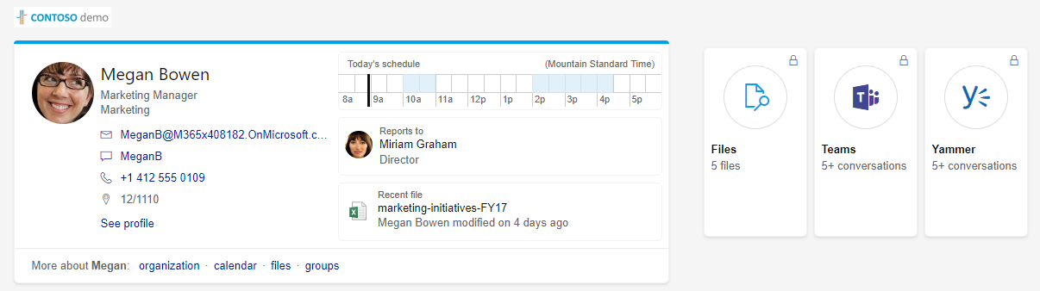

And as always, security is our top priority. Only authorized users can see our work results, this information isn't shared on the web, and you can only see information that you have access to. In addition, the searches are anonymized and not used for autosuggestion training or for personalized ads.
Watch for more news about Microsoft Search in Bing coming soon and give it a try today!
Sincerely,

<Insert name here>, <title>

