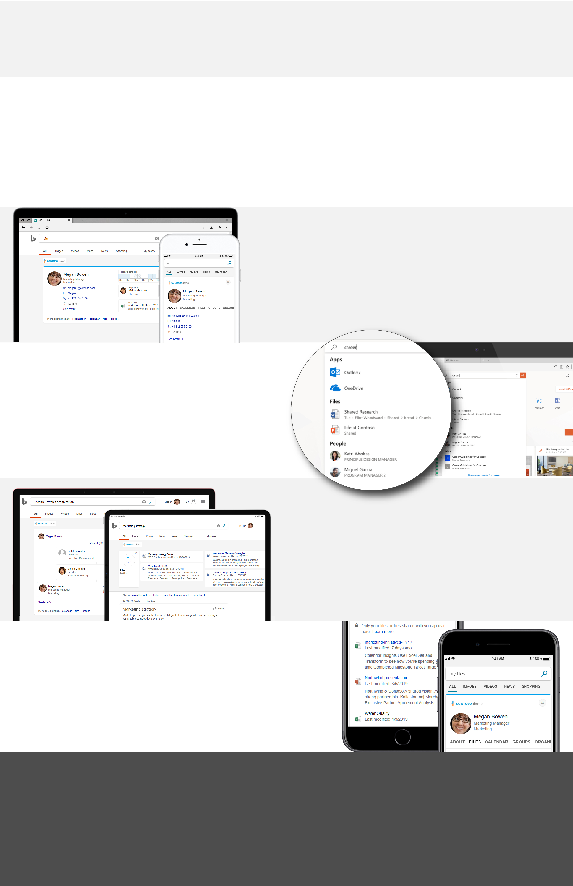Macintosh HD:Users:speaslee:Desktop:concept1.png­

<Add your message here: Lorem ipsum dolor sit amet, consectetur adipiscing elit. Donec mattis enim eu lorem malesuada hendrerit. Suspendisse eget quam et ipsum pretium ultrices. (200 characters max).>

Learn what you can find with Microsoft Search

Anywhere access – search from any device, anywhere

Personalized results – relevant to you and your work

One simple search – across Microsoft Search, your organization, and the web

Consistent and familiar – search from within   
any app or browser

Welcome to Microsoft Search — intelligent search for the modern workplace

Search smarter, not harder

<Insert your company’s logo here. Apply your company’s branding   
(fonts, colors, illustration or images) to the rest of the document as desired.>