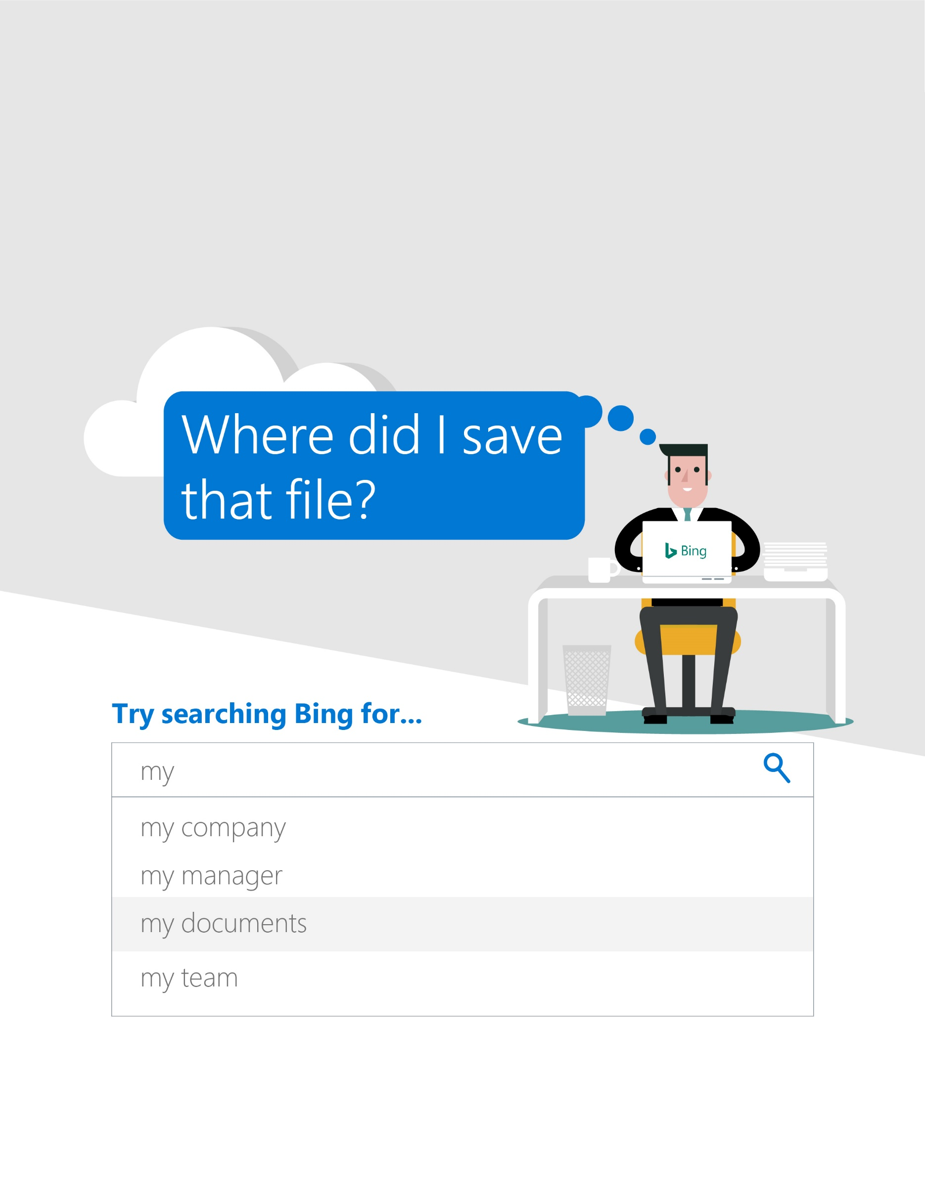

We’ve enabled  
Microsoft Search in Bing!

**Microsoft Search in Bing**  
Intelligent search for the modern workplace

[https://www.bing.com/Business/explore](https://nam06.safelinks.protection.outlook.com/?url=https%3A%2F%2Fwww.bing.com%2FBusiness%2Fexplore&data=02%7C01%7Cheidisc%40microsoft.com%7C741c5e45cb1f4f50052408d6f3432a72%7C72f988bf86f141af91ab2d7cd011db47%7C1%7C0%7C636963867138918362&sdata=9yOpal7mBTaCllLOJvruUZsH%2BKqzGicbHWSxEYVMZ3s%3D&reserved=0)