<Insert your company’s logo here. Apply your company’s branding (fonts, colors, illustration, or images) to the rest of the document as desired. Text in RED below should be modified/customized as needed for your organization. Note: to create links directly to Microsoft Search queries, use:
https://www.bing.com/business/search?q=searchterm1+searchterm2+…>

Subject Line: Microsoft Search in Bing Tip #5: Get where you need to be faster

When you have a meeting in a building you've never been to, Microsoft Search in Bing can help you find the location and get you there fast. Learn more in this quick video, or read on!

Where to go and how to get there
Start by signing in to Bing.com with your work account on any device, then search for the name of the building you want to find. For example:

<IT Admins – insert the names of building names relevant to your company>
- Building 25
- Seattle headquarters
- Production Studio G

You will see results related to our company at the top of the page (with regular web results below):

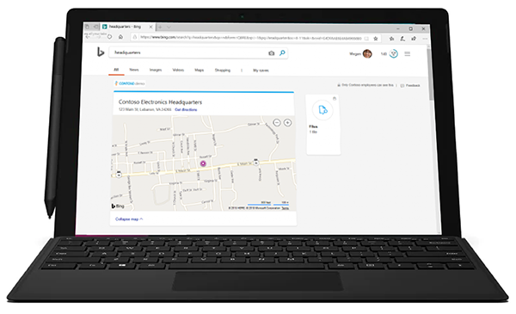

Need directions? Click ‘Get directions’ for turn-by-turn directions on Bing Maps.

Get more information
Learn more about what intelligent search can do to save you time at work on <LINK TO END-USER SharePoint> SharePoint </link>

Join us on <fill in date if you have scheduled training, or delete this line> for more information on getting started with using Microsoft Search in Bing.

We’re here to help you. Share your questions or feedback. <Insert email alias or Yammer group link, or customize this section with more information> Or click the Feedback link in the top-right section of your search results.

Explore training resources
- LINK
- LINK
- LINK

