Azure Active Directory Self-Service Group Management - Adoption Kit
Contents
Azure Active Directory Self-Service Group Management - Adoption Kit 1
Awareness 2
Business Overview 2
Pricing and Licensing Requirements 3
Key Benefits 3
Customer stories/Case studies 4
Announcements/Blogs 4
Training/Learning Resources 4
Level 100 Knowledge/Concepts 4
Role-Based Guidance 5
IT Administrator Staff 5
Help Desk Staff 6
Training 6
Videos 6
Online Courses 6
Books 6
Tutorials 7
End-user readiness and communication 7
Planning and Change Management 7
Deployment Plan 7
Architecture Plan/Topology 7
Testing 8
Deployment 8
Operations 9
Monitoring and Support 9
Troubleshooting 10
References 10
Support and Feedback 10

Awareness
This section helps you to analyze the benefits of Azure Active Directory (Azure AD) Group Management. You will learn about the ease of use, pricing, and licensing model, as well as customer stories about how it helped improve their business. You will also receive up-to-date announcements and access to blogs that discuss ongoing improvements.

Business Overview
Management of Azure AD Groups helps to accomplish tasks quickly and accommodate growth. You can use Groups in Azure AD to simplify tasks when you want to target many users for the operation. Within Azure AD, a Group is a collection of users and is primarily used to assign permissions to use resources. A user inherits the policies of the Group they are a member of.
There are two ways to add members to a Group:
- Assigned (static): Used when administrators and users add and remove members manually or
- Dynamic: Used when membership is determined by a query based on user properties.

You can change a group's membership from assigned (static) to dynamic (or vice-versa) In Azure AD. See Change static group membership to dynamic in Azure Active Directory.
Once groups are defined, you can use them as follows:
- In a Conditional access policy
Select specific users and groups in the policy. For example, you can select a group that contains all members of the HR department when an HR app is selected as the cloud app. A group can be any type of group in Azure AD, including dynamic or assigned security and distribution groups. See What are conditions in Azure Active Directory conditional access?
- Assign licenses
You can assign one or more product licenses to a group. Azure AD ensures that the licenses are assigned to all members of the group. Any new members who join the group are assigned the appropriate licenses. When they leave the group, those licenses are removed. See What is group-based licensing in Azure Active Directory?
- In SharePoint and Exchange online
You can use Azure AD to assign group access to the enterprise apps that are deployed in your Azure AD tenant. Using Azure AD Conditional Access, groups can control how users access your cloud apps such as SharePoint online and Exchange online. As an example, Microsoft Teams relies heavily on Exchange Online and SharePoint Online for core productivity scenarios, like meetings, calendars, and file sharing. Conditional access policies that are set for these cloud apps apply to Microsoft Teams when a user signs directly into Microsoft Teams. See How To: Set up SharePoint Online and Exchange Online for Azure Active Directory conditional access
- For application access
You can use groups to assign access to a SaaS application that's integrated with Azure AD. For example, if you want to assign access for the marketing department to use five different SaaS applications, you can create a group that contains the users in the marketing department, and then assign that group to those five SaaS applications that are needed by the marketing department. See Using a group to manage access to SaaS applications

Pricing and Licensing Requirements
Azure AD includes group-based licensing. You can assign one or more product licenses to a group. Azure AD ensures that the licenses are assigned to all members of the group. Any new members who join the group are assigned the appropriate licenses. When they leave the group, those licenses are removed automatically
For any groups assigned a license, you must also have a license for each unique member. While you don't have to assign each member of the group a license, you must have at least enough licenses to include all of the members. For example, if you have 1,000 unique members who are part of licensed groups in your tenant, you must have at least 1,000 licenses to meet the licensing agreement. See What is group-based licensing in Azure Active Directory?
The choice of Azure AD editions is dependent on the group management feature you need. For more information on pricing, refer to Azure Active Directory pricing.

Key Benefits
Here are the key benefits of using Azure AD Group Management:
Intuitive usage
Simple, easy to deploy, and customizable access portal. There are added policy controls for administrators and for owners of groups and enhanced visual design to provide a better experience for end users.
Security
Streamlined, simplified, and secured resource management. Administrators can set rules for groups that are created in Azure AD based on user attributes. This allows members to be automatically added to or removed from a security group. These groups can be used to provide access to applications or cloud resources and to assign licenses to members.
Cost-effective
Reduces the cost, time, and workload of IT support with self-service group membership. The self-service group management feature gives you the ability to delegate group management to your employees. With this feature they can create groups and manage memberships in groups they own.
Self-service
Delegates group management to your employees. The self-service group management feature capabilities enable employees to create groups and manage memberships in groups they own.

Customer stories/Case studies
Discover how Azure AD customers are gaining more insights into their on-premises identity solution with Azure AD Group Management. Read this featured story:
The George Washington University: Enhancing digital and physical security on campus with cloud-based identity and access management. “Dynamic group management for the students will ensure automatic access to the software and apps required by each program of study.”
To learn more about customer and partner experiences on Azure AD Group Management, visit See the amazing things people are doing with Azure.

Announcements/Blogs
Azure AD receives improvements on an ongoing basis. To stay up to date with the most recent developments, see What's New in Azure Active Directory.
Blogs by the Tech Community and Microsoft Identity Division:
- November 26, 2018, Ignite Recap 1: Automating the Identity Lifecycle Process
- November 02, 2018, Azure AD group-based license management is now generally available!

Training/Learning Resources
The section provides concepts, role-based guidance, online training and lists resources available on Azure AD Group Management.

Level 100 Knowledge/Concepts
Learn what Azure AD Group Management is and how it helps you perform access and resource management. See Users, groups, licensing, and roles for large organizations
Additionally, refer to the following links:
- Add/Remove/Update groups (Assigned):
  - Watch this video: How to configure and assign groups in Windows Azure AD?
  - How to Create a basic group and add members using Azure Active Directory?
  - How do you Edit your group information using Azure Active Directory
- Dynamic group:
  - Watch this video: Azure AD: Introduction to Dynamic Memberships for Groups
  - How to Create a dynamic group and check status
  - Dynamic membership rules for groups in Azure Active Directory
  - Change static group membership to dynamic in Azure Active Directory
  - Follow Tutorial: Add or remove group members automatically
- Group-based licensing:
  - What is group-based licensing in Azure Active Directory?
  - Assign licenses to users by group membership in Azure Active Directory
  - Scenarios, limitations, and known issues using groups to manage licensing in Azure Active Directory
- Conditional access
  - What are conditions in Azure Active Directory conditional access?
- Self-Service
  - Set up self-service group management in Azure Active Directory
- Access Reviews
  - How do you Manage app and resource access using Azure Active Directory groups?

Role-Based Guidance

IT Administrator Staff
The Global Administrator has access to all administrative features. By default, the person who signs up for an Azure subscription is assigned the Global Administrator role for the directory. Only Global Administrators and Privileged Role Administrators can delegate administrator roles. To reduce risk for your business we recommend that you assign this role to only a few people in your company.
For more information, refer to the links below:
- What are the Administrator role permissions in Azure Active Directory?
- How do you Delegate administration in Azure Active Directory?
- What are the default user permissions in Azure Active Directory?
- How are the Classic subscription administrator roles, Azure RBAC roles, and Azure AD administrator roles related?
- As a global administrator, how do you Elevate access to manage all Azure subscriptions and management groups?
The IT admin can refer to the following links for group management:
- Add/Remove/Update groups (Assigned)
  - How to Create a basic group and add members using Azure Active Directory?
  - How do you Edit your group information using Azure Active Directory
  - How to Add or remove a group from another group using Azure Active Directory?
  - How to Add or remove group members using Azure Active Directory?
  - How to Add or remove group owners in Azure Active Directory?
- Dynamic groups
  - How to Create a dynamic group and check status?
  - Dynamic membership rules for groups in Azure Active Directory
  - Change static group membership to dynamic in Azure Active Directory
  - Follow Tutorial: Add or remove group members automatically
- Group-based licensing
  - What is group-based licensing in Azure Active Directory?
- Conditional access
  - What are conditions in Azure Active Directory conditional access?
  - How To: Set up SharePoint Online and Exchange Online for Azure Active Directory conditional access
- PowerShell
  - How do I manage az ad group using PowerShell?
  - PowerShell examples: Azure Active Directory version 2 cmdlets for group management
  - What are the Azure Active Directory cmdlets for configuring group settings?
- Self-Service
  - Set up self-service group management in Azure Active Directory
- Access Reviews
  - How do you Manage app and resource access using Azure Active Directory groups?

Help Desk Staff
- Search the Microsoft Support Knowledge Base for solutions to common technical issues.
- Search for and browse technical questions and answers from the community, or ask your own question in the Azure Active Directory Forum.

Training

Videos
- Azure videos: Azure AD: Introduction to Dynamic Memberships for Groups
- YouTube: Azure Management Group in Enterprise Mobility Suite
- Channel 9: How to configure and assign groups in Windows Azure AD?
- Channel 9: Azure Active Directory Core Skills: Azure AD Users, Groups, and Authentication
- LinkedIn Learning: Office 365: Manage Identities using Azure AD Connect

Online Courses
- PluralSight.com: Managing Identities in Microsoft Azure Active Directory
“In this course, you will learn the basics of managing an Azure Active Directory environment, including users, groups, devices, and applications.” Azure AD groups are covered in the “Managing Azure Active Directory Users and Groups” module.
- PluralSight.com: Managing Microsoft Azure Active Directory
“This course explores the key management activities and actions related to Azure Active Directory.” Azure AD groups are covered in the “User and Group Management Using the Azure Portal” module.
- PluralSight.com: Getting Started with the Microsoft Enterprise Mobility Suite
“This course will provide best practices that you need to know for extending on-premises assets to the cloud in a manner that allows for authentication, authorization, encryption, and a secured mobile experience.” Learn how to configure dynamic groups in the “Configuring Advanced Features of Microsoft Azure Active Directory Premium” module.

Books
Oreilly: Mastering Identity and Access Management with Microsoft Azure by Jochen Nickel
“Beginning with the basics of features and licenses, this book quickly moves on to the user and group lifecycle required to design roles and administrative units for role-based access control (RBAC). Get to grips with how to configure and manage users, groups, roles, and administrative units to provide a user- and group-based application and self-service access including the audit functionality.” Group management is covered in the “Planning and Designing Cloud Identities” chapter.

Tutorials
- Quickstart: View your organization's groups and members in Azure Active Directory
In this QuickStart, you view all your organization's existing groups and view the assigned members.
- Quickstart: Set Office 365 groups to expire in Azure Active Directory
In this QuickStart, you set the expiration policy for your Office 365 groups. When users can set up their own groups, unused groups can multiply.
- Quickstart: Naming policy for groups in Azure Active Directory
In this QuickStart, you set up a naming policy in your Azure Active Directory (Azure AD) tenant for user-created Office 365 groups, to help you sort and search your tenant’s groups.
- Tutorial: Add or remove group members automatically
In this tutorial, you learn how to:
  - Create an automatically populated group of guest users from a partner company
  - Assign licenses to the group for the partner-specific features for guest users to access
  - Bonus: secure the All users group by removing guest users so that, for example, you can give your member users access to internal-only sites

End-user readiness and communication
There is no end-user content specifically required for enabling this feature.

Planning and Change Management
This section provides the deployment plan, prerequisites and high-level design to plan the Azure AD Group Management deployment.

Deployment Plan
Coming soon!

Architecture Plan/Topology
Azure AD helps you to manage cloud-based apps, on-premises apps, and your resources using your organization's groups. Your resources can be part of the directory, such as permissions to manage objects through roles in the directory, or external to the directory, such as for Software as a Service (SaaS) apps, Azure services, SharePoint sites, and on-premises resources.
How does group management in Azure AD work?
Azure AD helps you give access to your organization's resources by providing access rights to a single user or to an entire Azure AD group. Using groups lets the resource owner (or Azure AD directory owner), assign a set of access permissions to all the members of the group, instead of having to provide the rights one-by-one.
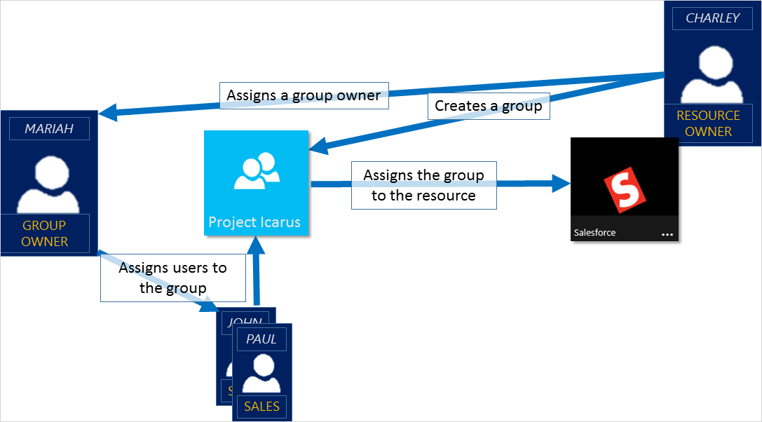
There are four ways to assign groups. See Ways to assign access rights.
The group owner can let users find their own groups to join, instead of assigning them. The owner can also set up the group to automatically accept all users that join or to require approval. For more information and instructions about how to let your users request to join groups, see Set up self-service group management in Azure Active Directory.

Testing
This section provides the plan to test the functionality of Azure AD Group Management in a sandbox or test lab environment before the customer rolls it into production.
<Not available>

Deployment
How can I get Azure AD Group Management deployed in my environment? This section provides resource links to help with implementation of your solution.
Refer to the following links:
- Add/Remove/Update groups (Assigned)
  - How to Create a basic group and add members using Azure Active Directory
  - How To Edit your group information using Azure Active Directory
  - How to Add or remove a group from another group using Azure Active Directory
  - How to Add or remove group members using Azure Active Directory
  - How to Add or remove group owners in Azure Active Directory
- Dynamic groups
  - How to Create a dynamic group and check status?
  - Dynamic membership rules for groups in Azure Active Directory
  - Change static group membership to dynamic in Azure Active Directory

You can delegate the group management to employees using self-service. To enable self-service group management, see Set up self-service group management in Azure Active Directory

Operations
How do I manage and maintain Azure AD Group Management? This section provides troubleshooting info, Azure AD Connect Health operation and management details, and other important references.
Once the groups are defined, you can use them for one or more of the following:
- Conditional access
  - What are conditions in Azure Active Directory conditional access?
- Group-based licenses
  - What is group-based licensing in Azure Active Directory?
  - QuickStart: Assign or remove licenses using the Azure Active Directory portal
  - How to add migrate users with individual licenses to groups for licensing
  - Assign licenses to users by group membership in Azure Active Directory
  - Change the license for a single user in a licensed group in Azure Active Directory
  - Azure Active Directory group-based licensing additional scenarios
  - PowerShell examples for group-based licensing in Azure Active Directory
- SharePoint and Exchange online
  - How To: Set up SharePoint Online and Exchange Online for Azure Active Directory conditional access
- SaaS App access
  - Using a group to manage access to SaaS applications

Monitoring and Support
You can manage your groups in Azure AD using the following methods:
- Admin-managed
  - Elevate access to manage all Azure subscriptions and management groups
- Self-Service
  - Set up self-service group management in Azure Active Directory.
- Access reviews
  - Manage user access with Azure AD access reviews so that the right users have the right access.
- PowerShell cmdlets and API
  - What are the Azure Active Directory cmdlets for configuring group settings?
  - Download the Azure AD PowerShell module.
  - PowerShell examples : Azure Active Directory version 2 cmdlets for group management

Troubleshooting
Refer to the following links:
- Troubleshoot and resolve groups issues
- Identify and resolve license assignment problems for a group in Azure Active Directory

References
Additionally, you can refer to:
- Azure AD Connect sync: Understanding Users, Groups, and Contacts
- Authorization in a web app using Azure AD groups & group claims
- Working with Azure Active Directory resources in Microsoft Graph

Support and Feedback
How can we improve Azure AD Group Management? This section provides links to discussion forums and technical community support email IDs.
The product documentation for Azure AD Group Management is available online. There you can use the built-in search or your favorite search engine to find information on Azure AD Connect Health.
If you have a general question about Azure AD and Azure AD Group Management, you can ask the community for assistance on the Azure AD forums.
We encourage you to join our Technical Community, a platform to Microsoft Azure Active Directory users and Microsoft to interact. It is a central destination for education and thought leadership on best practices, product news, live events, and roadmap.
If you have suggestions, please submit an idea or vote up an idea at our User Voice Channel - feedback.azure.com.

