<Insert your company’s logo here. Apply your company’s branding (fonts, colors, illustration, or images) to the rest of the document as desired. Text in RED below should be modified/customized as needed for your organization. Note: to create links directly to Microsoft Search queries, use:
https://www.bing.com/business/search?q=searchterm1+searchterm2+…>

Subject Line: Microsoft Search in Bing Tip #3: Find <company name> resources easily

How many times have you tried to remember the URL for our human resources website? Or needed to book travel for an upcoming meeting? Microsoft Search in Bing saves you time by surfacing our important company sites with a simple search.

Find it fast
Sign in with your work account to Microsoft Search in Bing on your desktop or mobile, and search—it’s that fast and easy. Try these searches:

- human resources
- Time off
- Company holidays

Try it on your desktop and your mobile; it works wherever you are, as long as you’re signed in.

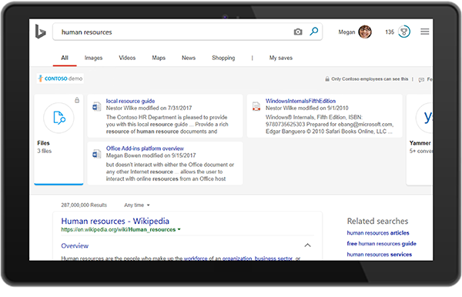

Help us add sites
If you don’t find what you’re looking for, use the “suggest” link or email us @<Your IT Admin inbox>.

Get more information
Learn more about what intelligent search can do to save you time at work on <LINK TO END-USER SharePoint> SharePoint </link>

Join us on <fill in date if you have scheduled training, or delete this line> for more information on getting started with using Microsoft Search in Bing.

We’re here to help you. Share your questions or feedback. <Insert email alias or Yammer group link, or customize this section with more information> Or click the Feedback link in the top-right section of your search results.

Explore training resources
- LINK
- LINK
- LINK

